*************************************************************************************

**LEARNING SPRING WITH SPRING BOOT**

*************************************************************************************

* **Spring** provides comprehensive support for developing Java applications. It provides the “plumbing” so the developer can focus on the business logic.
* Spring also supports strong object-oriented programming practices and encourages “Don’t Repeat Yourself” principles.

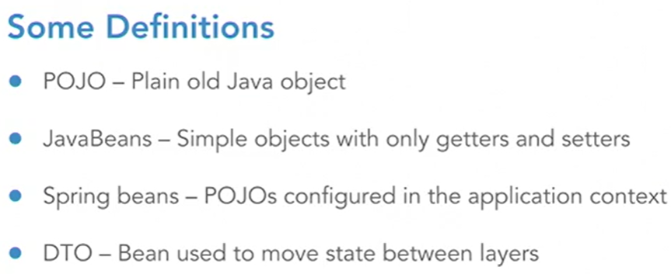

* **Inversion of Control** is the pattern that Spring is primarily based on. The IoC container in Spring provides a mechanism for dependency injection within the framework.

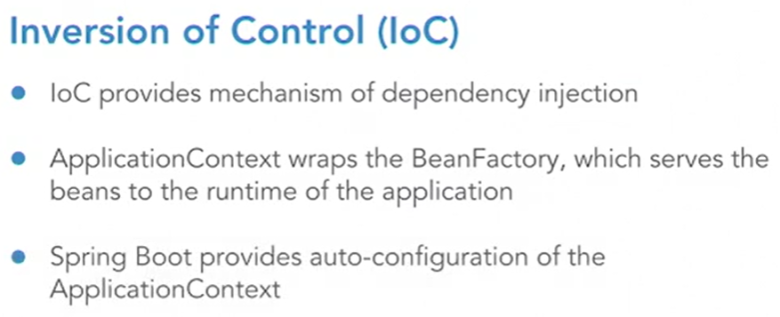

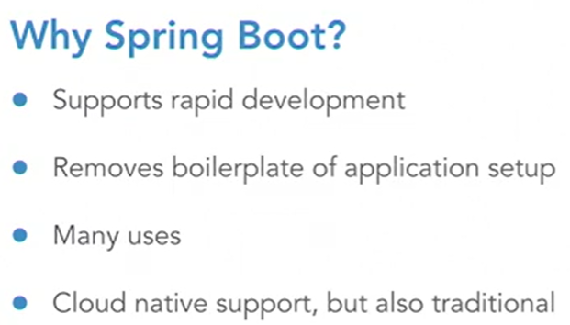

* Projects can either be obtained with Spring Initializer [**http://start.spring.io**](http://start.spring.io) or by using the IDE.
* The **pom.xml** file displays information about the project configuration.
* **Main information about Spring version is shown below:**

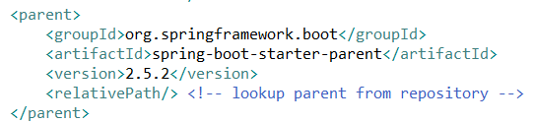

* **Dependencies are shown below:**

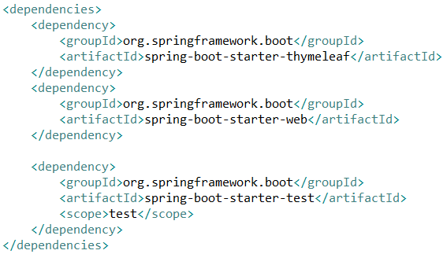

* The Maven plugin shown below was used to generate the .jar file of the project:

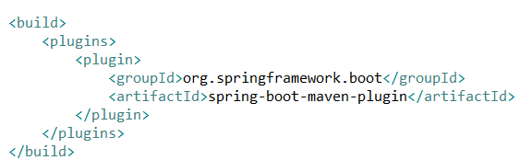

* The **@SpringBootApplication** annotation designates a configuration file, as well as the starting point of the component scanning. It gets us all of the auto-configuration based on the JARs that are on the classpath.
* If port 8080 is already in use when running an application, specifying *server.port=XXXX* in “application.properties” file will solve the issue.
* In order to embed a database in Spring Boot, the following lines need to be added in *pom.xml* and *application.properties*, respectively:

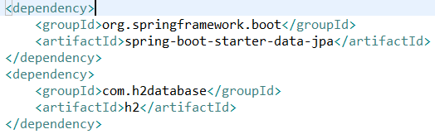



* Spring Data provides interfaces for interacting with an underlying SQL or NoSQL data store.

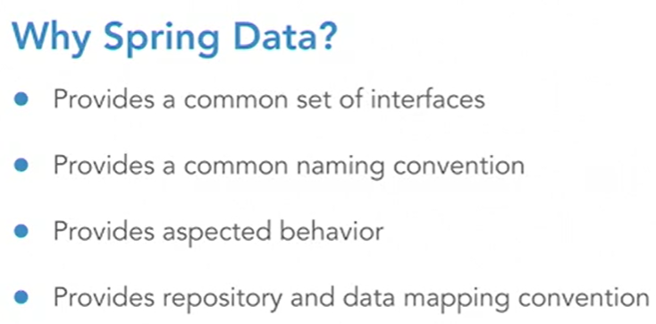

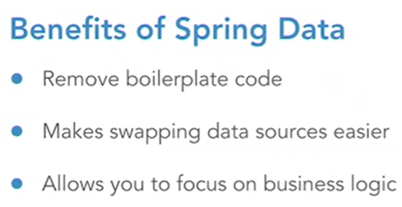

* **Spring Data** operations have two main components:
  + Repository – a primary construct for interacting with data access across Spring.
  + Entity – provides the data object from representing the table or document from the database.
* Make sure that Postgres is installed in your computer and added to the PATH before creating Postgres DBs with Docker.
* Preferably use absolute paths when creating Postgres DBs in Docker.
* To copy files from the local machine into the container, make sure to use the commands below:

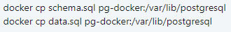

* The *entity* object and the type of *ID attribute* are the template variables of a **repository interface**.
* Dependency Injection is the core of Spring Framework. It allows to focus on the contracts of the APIs you are developing.

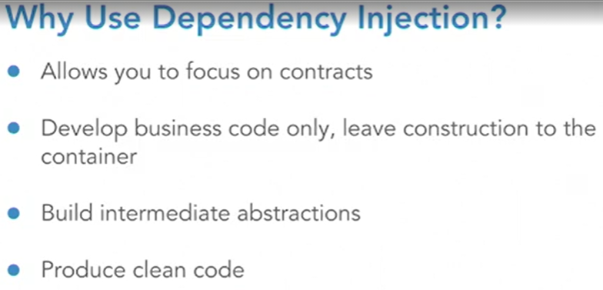

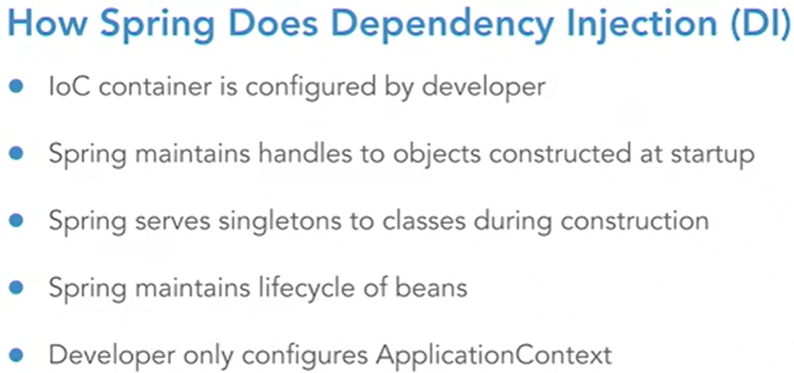

* Service classes should have the **@Service** annotation on top of them. Also, domain classes used by the service class should be defined in the corresponding package. Java or XML Config are other ways of getting the Spring IoC container configured with the new class.
* The **Model-View-Controller (MVC) pattern** allows for separation of concerns, as well as managed, repeatable pattern for handling visual display of data, merged with static content. The *model* is the dynamic aspect of the visual display, as it is the data that gets populated into a static view in a web application. The *view* is the static component of a web application, usually a HTML structure. The *controller* is the business end of the pattern, selecting the view, collecting the data for the model, populating the model, and then wiring all together to display a visual for the end-user to consume.

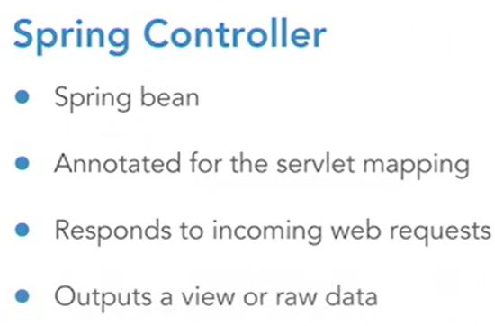

* The **RestController** is the most efficient way to write JSON based restful web services in Spring. Controllers are used not only to map a URL to a method, but also to serve the data out of the web service itself.

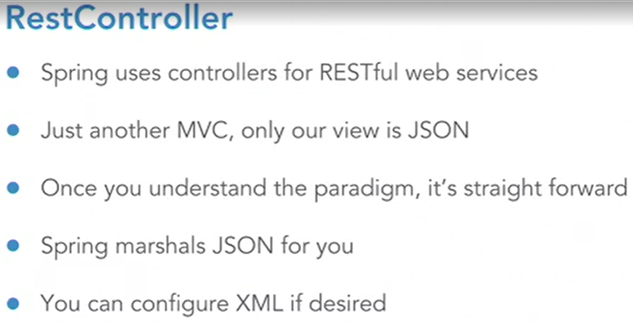

*************************************************************************************

**SPRING BOOT 2.0 ESSENTIALS**

*************************************************************************************

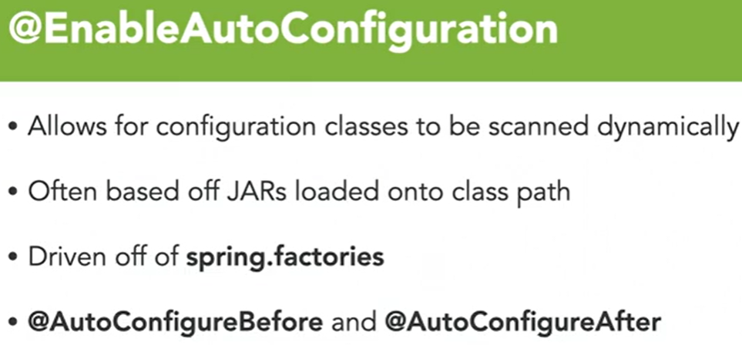

* Some **Conditional Loading** allows for configurations to only be loaded when and if there are classes specifically on the classpath, such as the *@ConditionalOnclass* annotation. You can also drive configuration off the presence of a bean being defined in the application context.

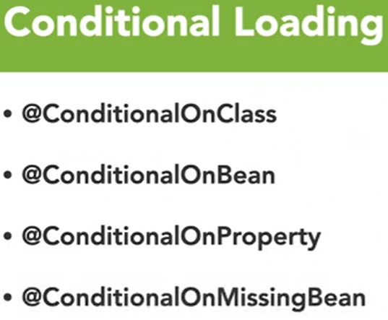

* **Properties** are also a big part of the default configuration for Spring Boot. Many projects include pre-configured default properties for the auto-configuration classes themselves.

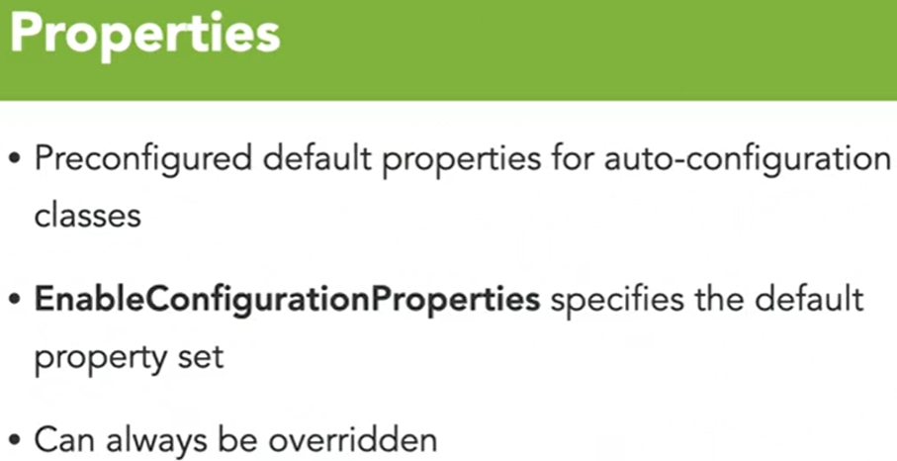

* application.properties and application.yaml provide very basic configuration, and are best suited for developing and demoing purposes only.

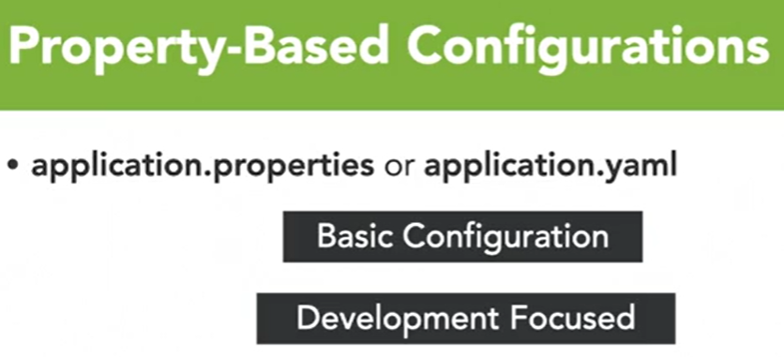

* The most common way to modify properties is through **Cloud Configurations**.
* Another way to modify the configuration is through the beans that are actually defined as part of the application context.

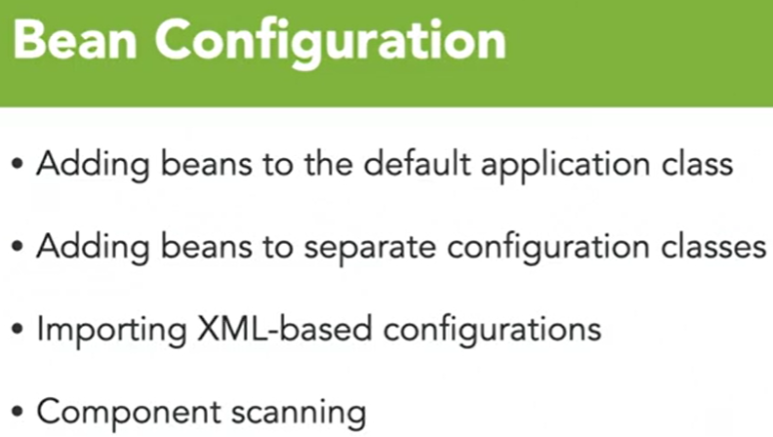

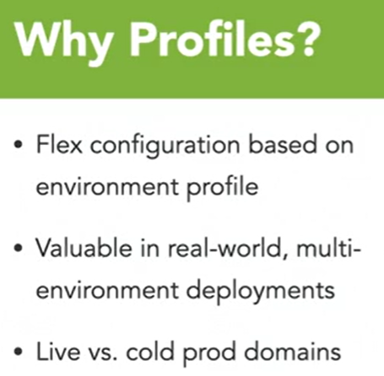

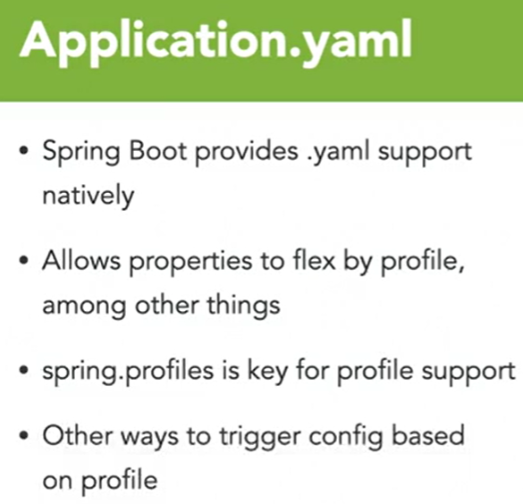

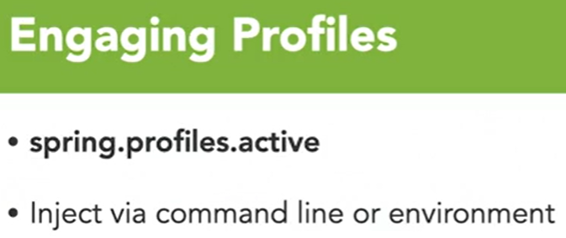

* Building Spring Boot applications is simple because you’re using the build systems in place from the dependency management systems. With **Maven** you simply execute a Maven clean package command, while **Gradle** allows to use simple build commands defined in the Gradle file itself. Regardless of those two tools, Spring Boot comes packaged with scripts that call into the build independency management system for you.
* Except for Docker, all the build systems mentioned before produce an executable JAR, or an executable WAR.
* Spring Boot applications are best suited as JAR files. You can simply use the command line to run the application without any other needs from the systems, other than having a JVM installed. The JAR itself can be deployed to some containerized frameworks to run in an unpacked form.
* Spring Boot JAR files have some prepended text that allow them to run on servers via *init.d* or *systemd* registrations.
* If there are errors showing that the JAR file could not be found when running a Docker build, first run *mvn clean package* and then run the Dockerfile build again. Once the Dockerfile build is run, enter the following command in CLI: *docker build -t <projectName> .* and then enter this one to run the container: *docker run -p 8080:8080 -d <projectName>*
* **Tomcat** is the embedded server in Spring. However, it can be replaced for another server and it can even be removed completely and have a WAR file created instead. Keep in mind that the default Tomcat configuration may not be the best for real-world examples.

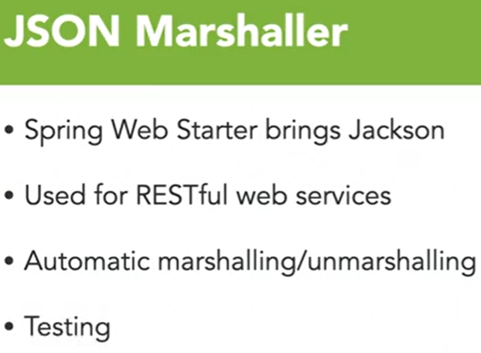

* Spring Boot also has its own **logging** framework, which is SLF4J. However, the user can build their own loggers if wanted. Properties can be leveraged to modify the logging, the logging formats, or the log level itself.

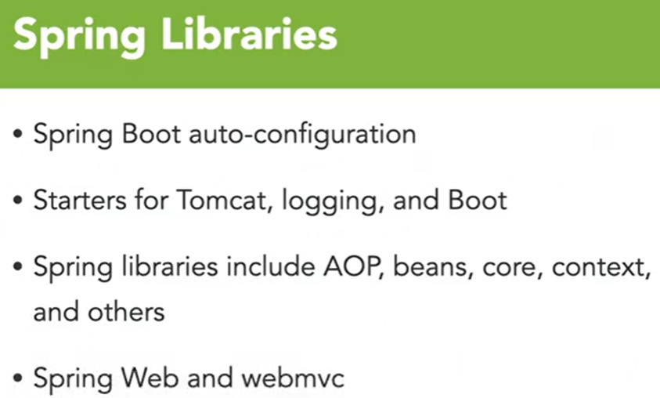

* Configuring Tomcat is critical because organizations have specific requirements on how communications are to operate over a web-enabled network, so they’ll want to know how to configure the servlet container that their application will be running in.
* If the user wants to add their own servlet, filter, or listeners, they will need to **configure the servlets**. There are two options for that:
  + Go into one of the Configuration Classes or create new one and annotate a method with *@Bean*, that serves one of these objects.
  + Annotate the actual class file with *@WebServlet, @WebFilter* or *@WebListener*, and allow it to be component scanned and put into the embedded container.

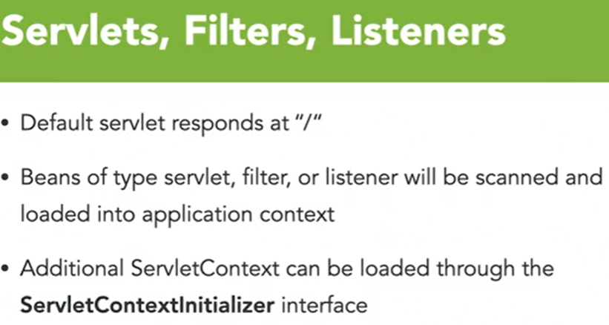

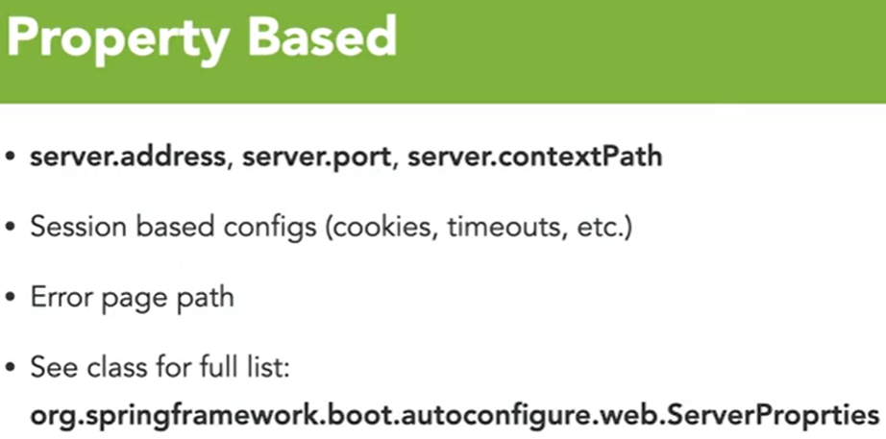

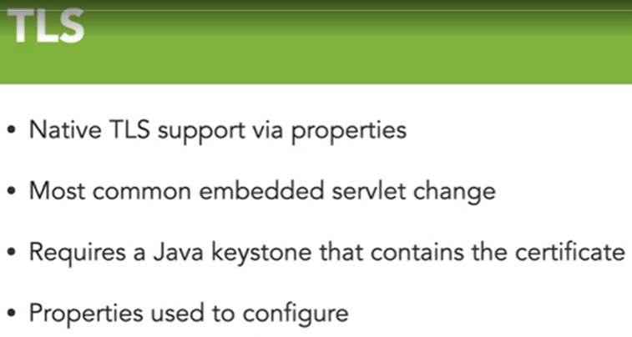

* Spring Boot **web services** use an MVC implementation but in this case the *view* is the content type of the page and not HTML. *RestController* is used instead of *Controller* in order to not map to a view. Instead, an object that has been marshaled is returned. JSON is the default output type for the view, but things like XML can be added if needed.
* The **repository pattern** is critical for Spring Data.

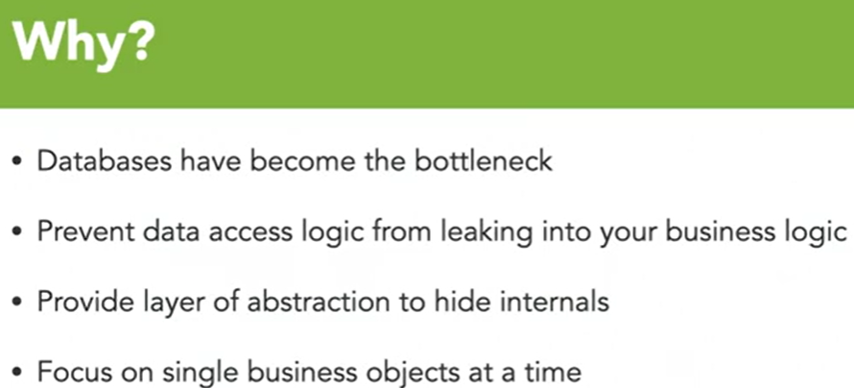

* Below is the general creation strategy used when building a repository:

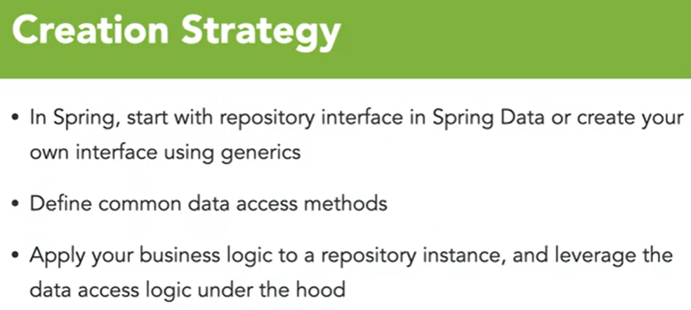

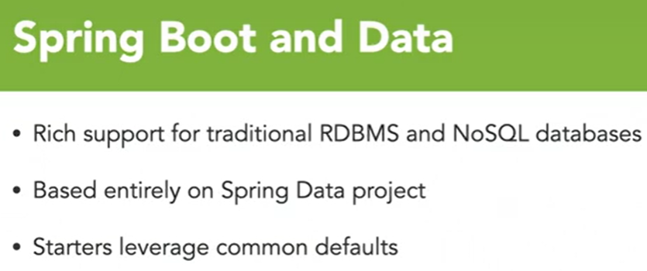

* Part of configuring a database in a Spring Data project is getting the **database drivers** correct. Not only the driver classes but also the URL, username, password, and so on. When you include a database technology into your classpath, you will get a set of properties built that you can use to populate so that Spring will either auto-configure or take your property overrides to build the database drivers for you.

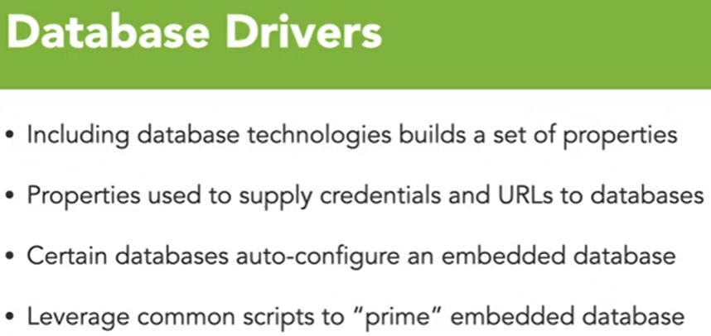

* **Data Sources** are created with the project itself, and then auto-configured.

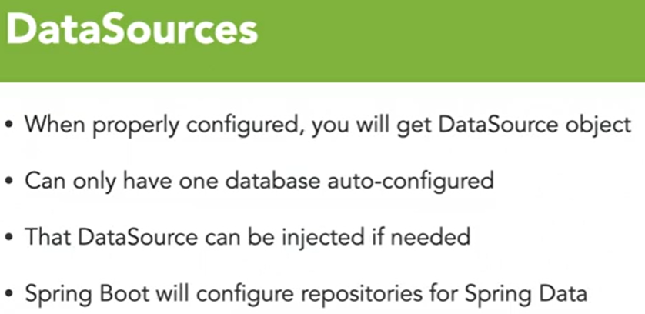

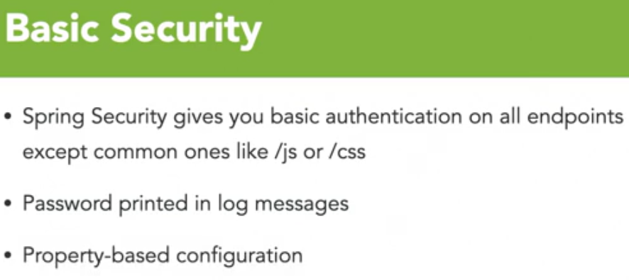

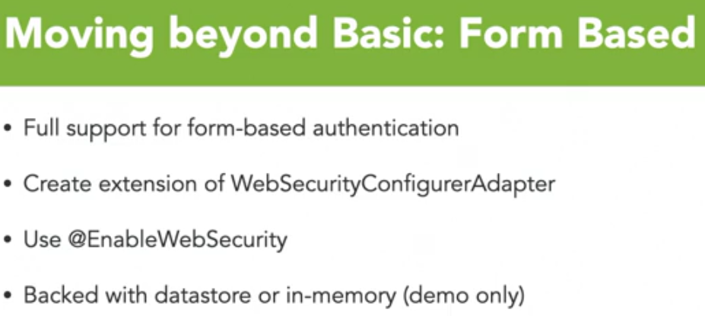

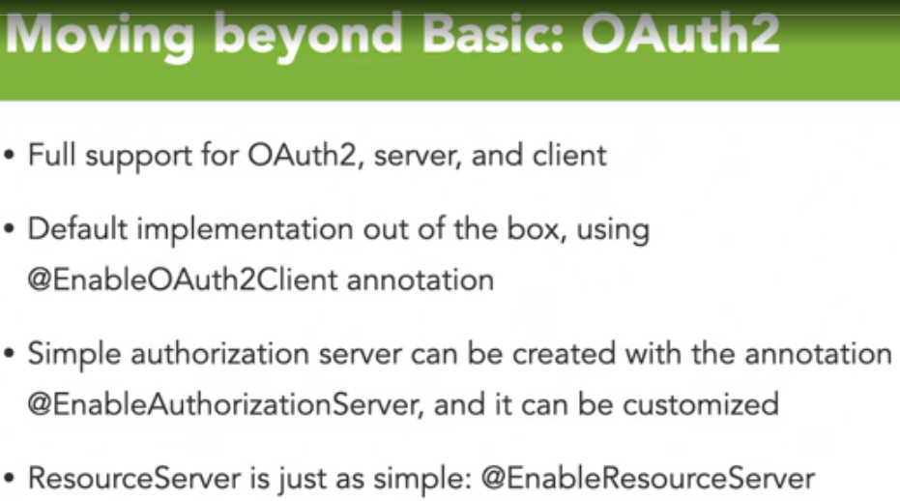

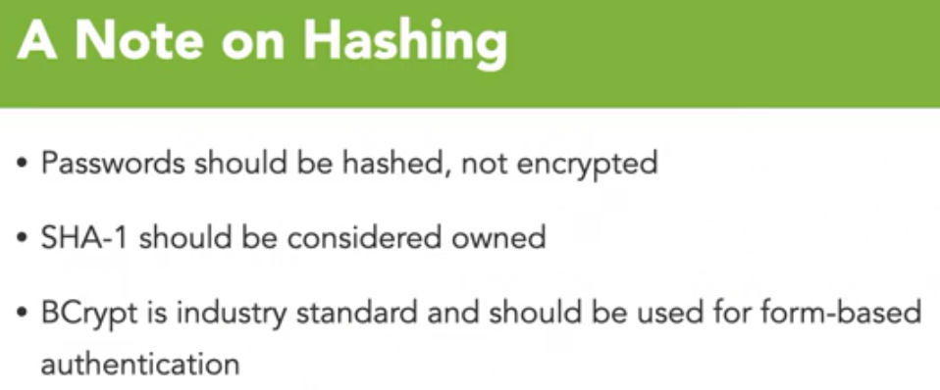

* Rarely is real-time processing a requirement. **Asynchronous messaging** as a whole, when done correctly, can reduce the overall strain of your system. Efficiency in sending and receiving also make the primary systems more efficient by removing blocking calls.
* There are two main sides in asynchronous messaging: **producer** and **consumer**.
* The *Producer* generally requires the use of a template and Spring provides one.

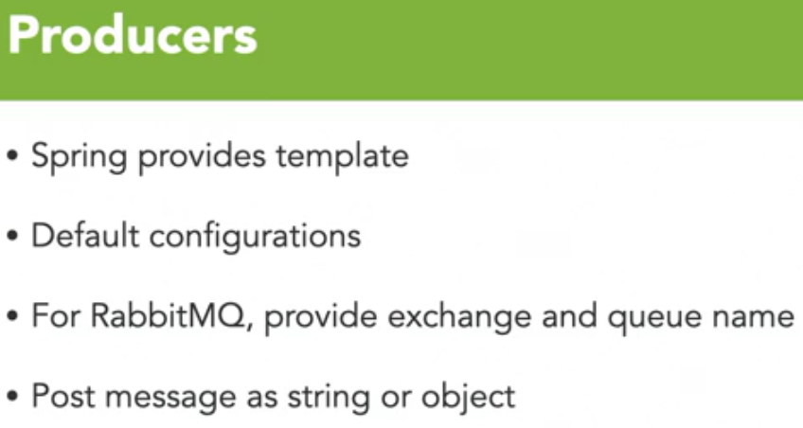

* To *consume* messages, you create a message listener first and then Spring receives the message from a queue and initiates the listener response.

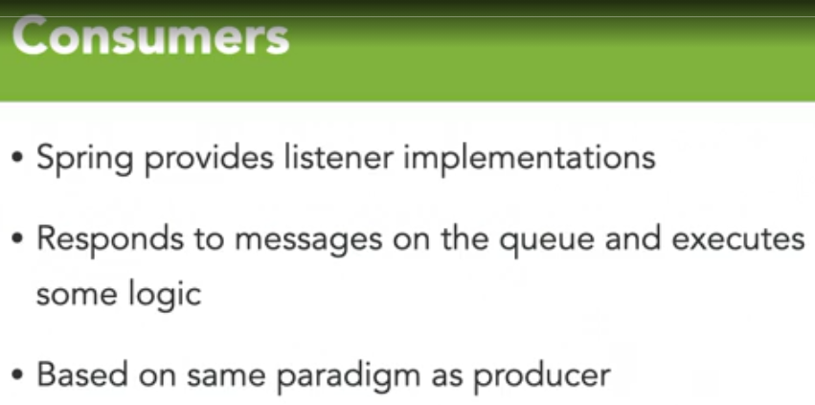

* Each application needs to provide details of its up status as well as other metric details, and this is where the **Actuator** comes into picture.

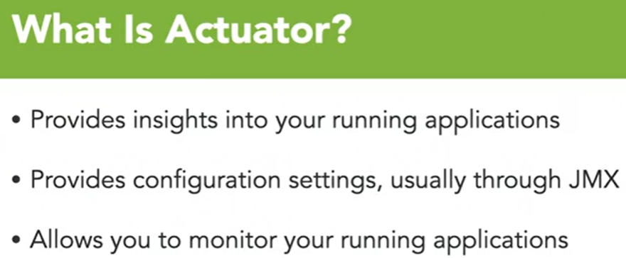

* One of the main endpoints obtained with Actuator is the *health endpoint*.

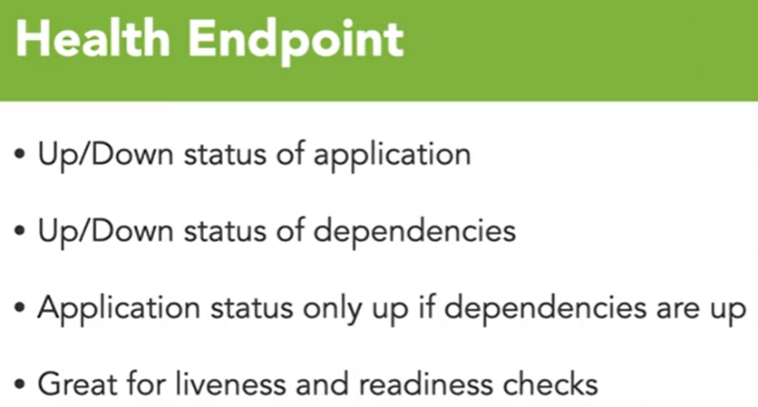

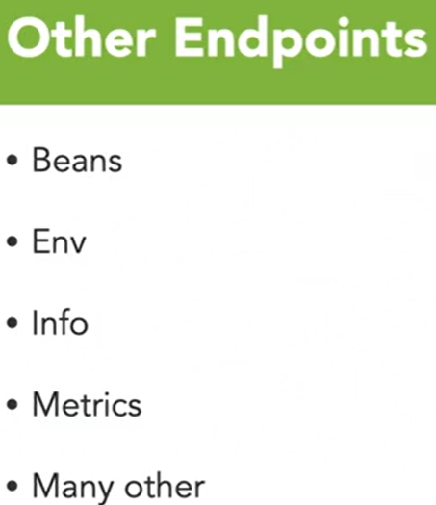

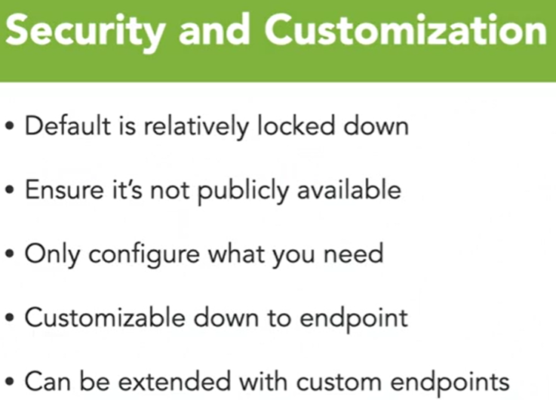

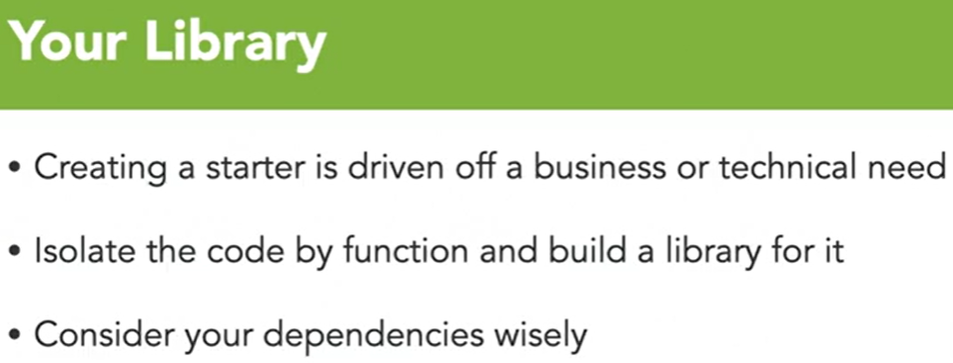

*************************************************************************************

**SPRING: FRAMEWORK IN DEPTH**

*************************************************************************************

* If you build your applications using best practices and current recommended strategies, you can dramatically reduce the dependency on imports from the Spring catalog. Through the use of abstractions and façades you can actually keep your business logic completely intact while not requiring any Spring imports in those class files.

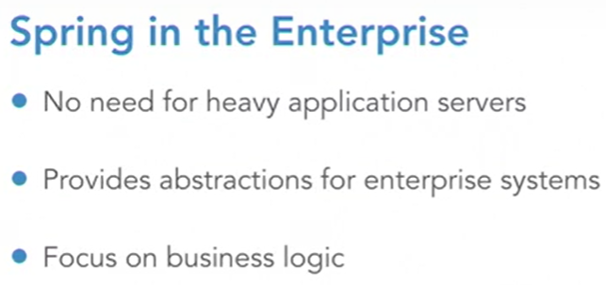

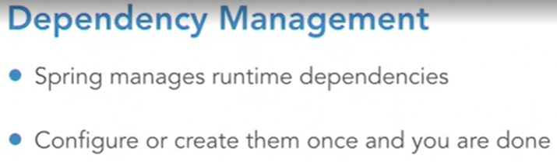

* With **Inversion of Control (IoC)**, the container itself maintains all of the classes including the dependency classes. Objects are injected at runtime, usually during a startup operation. This allows the container to maintain the objects and hand them as dependencies to other objects within that runtime. An object that accepts these dependencies usually does this through construction of the object itself or through setter injection.
* If your class cannot operate without a dependency, it should be injected via constructors. Otherwise, if your class can treat the dependency as optional or can accept multiple but variable concrete instances of the dependency, then it can be injected via setter injection.

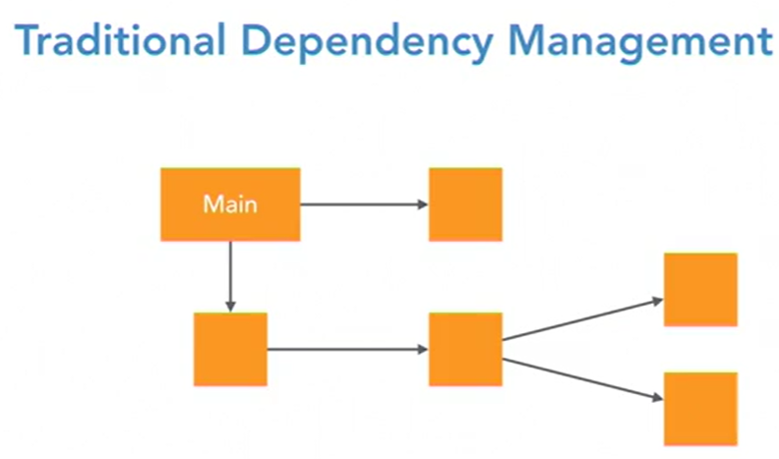

* In the IoC pattern, once again main has two dependencies. However, instead of constructing them, it takes them as constructor arguments and the IoC Container handles the injection at object creation for main. Because we only configure these classes once, no matter how many times that dependency is used, and once we create it we don’t have to worry about it again.

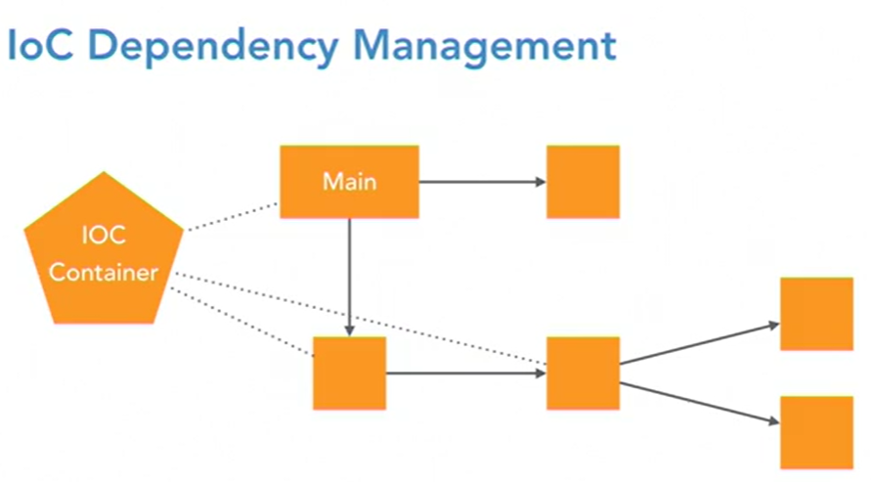

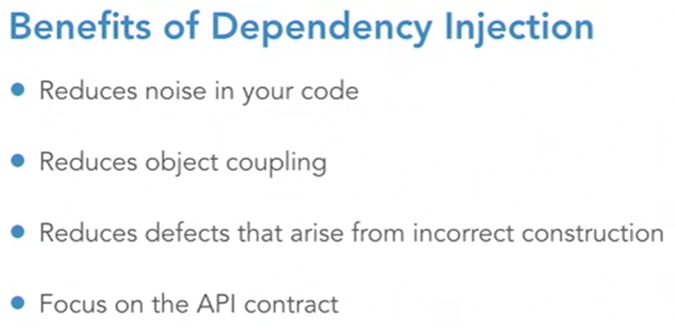

* The **Application Context** acts as the heart of the Spring Application. It is the central element that you deal with from the Spring framework, when developing an application. Classes should rarely, if ever, have imports from the Spring Framework, except for annotations.
* The Application Context encapsulates the **Bean Factory**, which is the IoC Container itself.

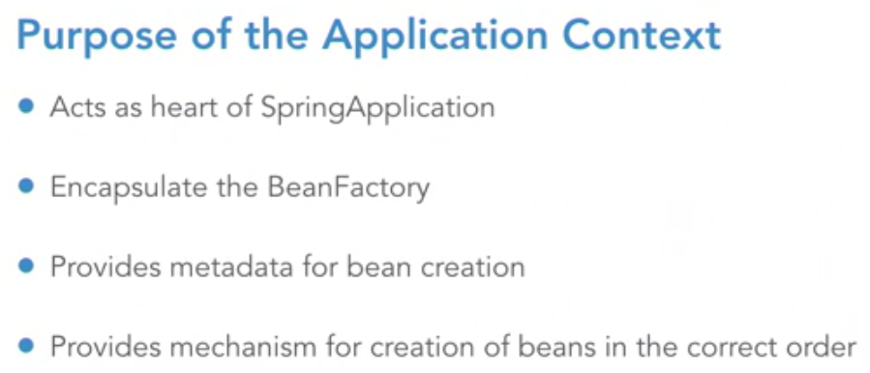

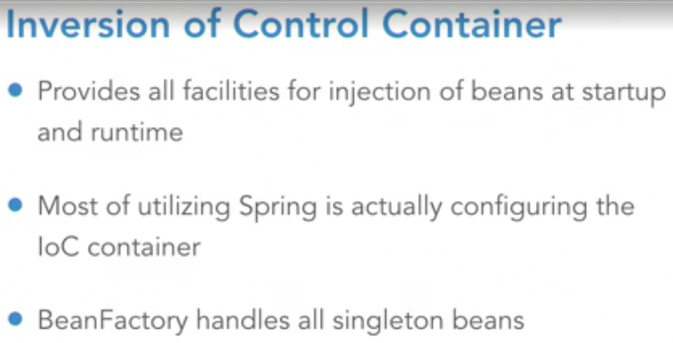

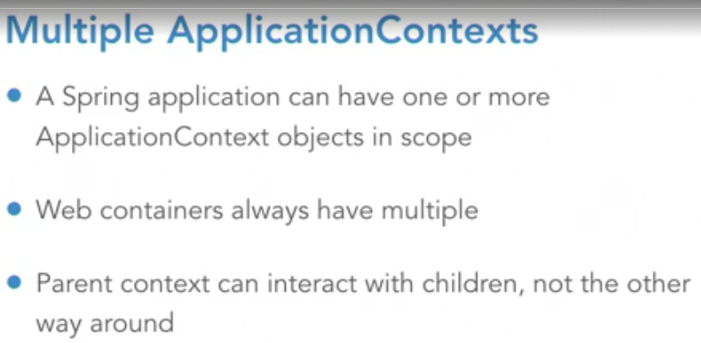

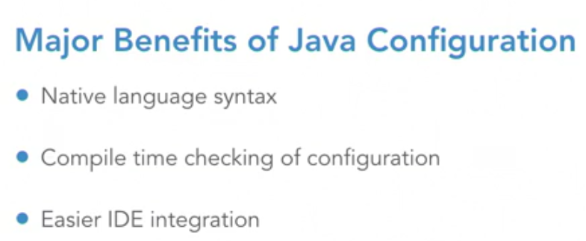

* The use of **Environment Variables** **and Properties** is one of the most common ways of injecting data into a running application to flex by things like data centers or environments.

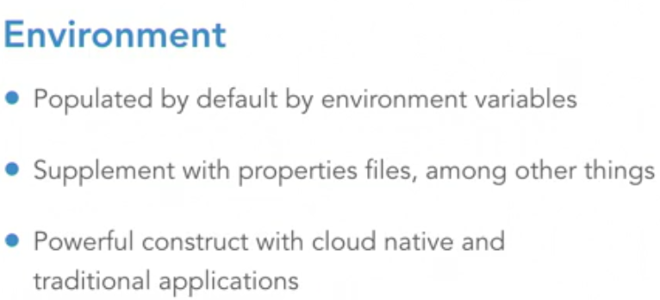

* Declaring multiple Beans to express **profiles** isn’t ideal in all the situations.

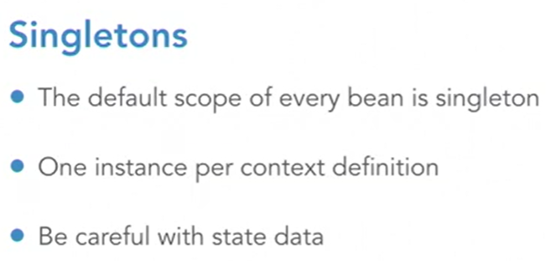

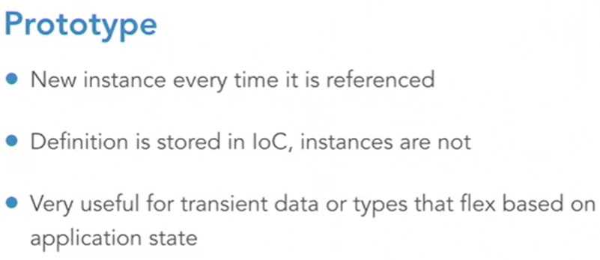

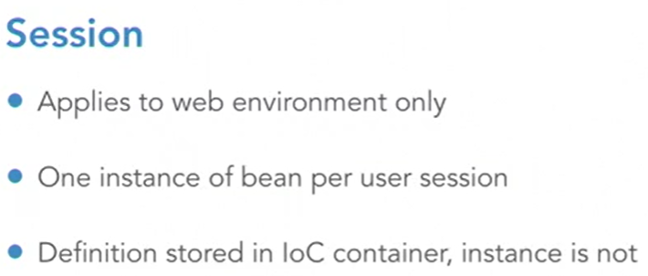

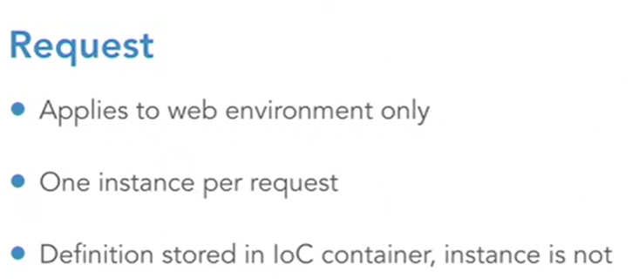

* **Proxies** are aspected behavior that is applied to your classes by the framework under various conditions.

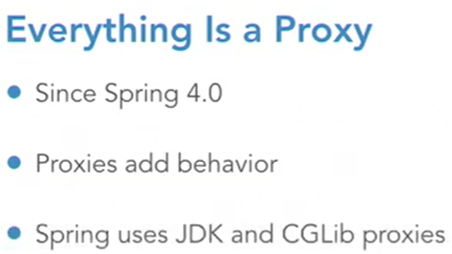

* In Spring Boot, the auto-configuration is partially achieved through **component scanning**. The root annotation that is used for this task is *@Component*. This annotation indicates that the class should be loaded into the BeanFactory and configured using annotations and inspections of the class itself.
* There are several stereotypes of Component that can be used. Stereotypes like *@Service* allow you to write your own aspects to add behavior to your classes based on type. Component Scanning uses other annotations to direct the IoC container to build the dependency graph.

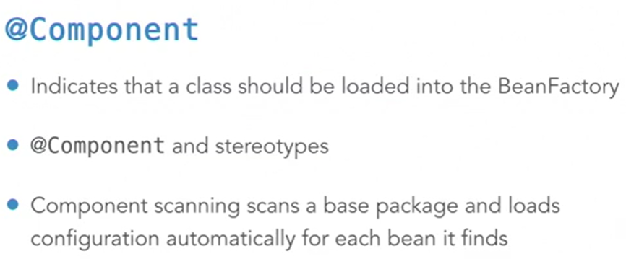

* The **@Autowired** annotation instructs the IoC container to inject a bean into the needed value at that point. The annotation should be used only on methods and not on class attributes, preferably. If a dependency is required, it should be set on the constructor. Otherwise, it should be on the setter.

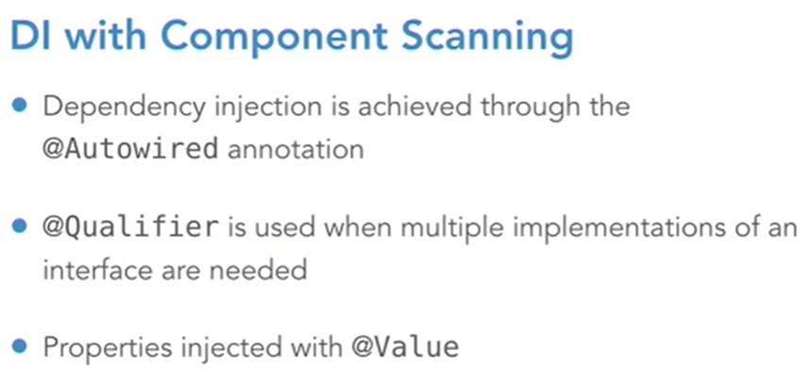

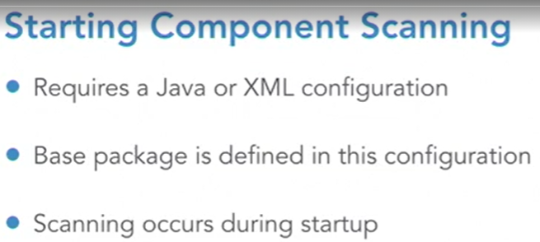

* **Lifecycle Methods** – sometimes you have a behavior that needs to be performed within a class, that requires the dependency injection to be completed, but this behavior either needs to be done before the application is ready to use or right before it’s destroyed.
* *@PostConstruct* should be executed after the construction of the object.

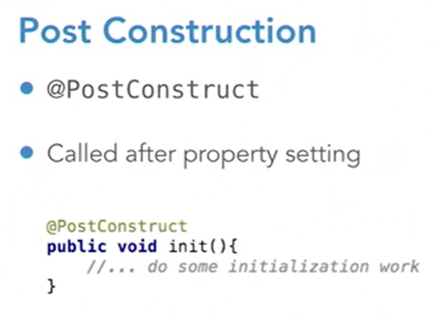

* *@PreDestroy* is executed before the class itself is marked for garbage collection.

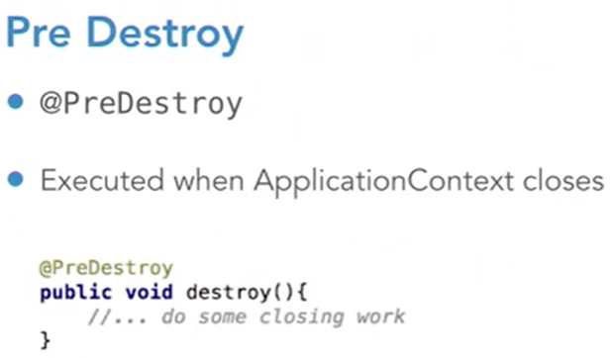

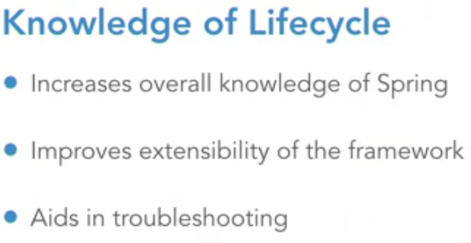

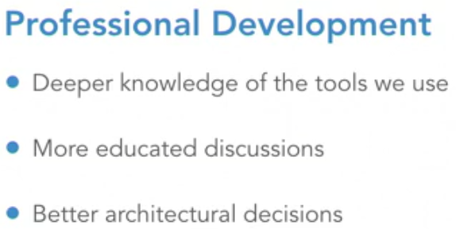

* In the **Initialization phase** is where we can impact the behavior of our application the most.

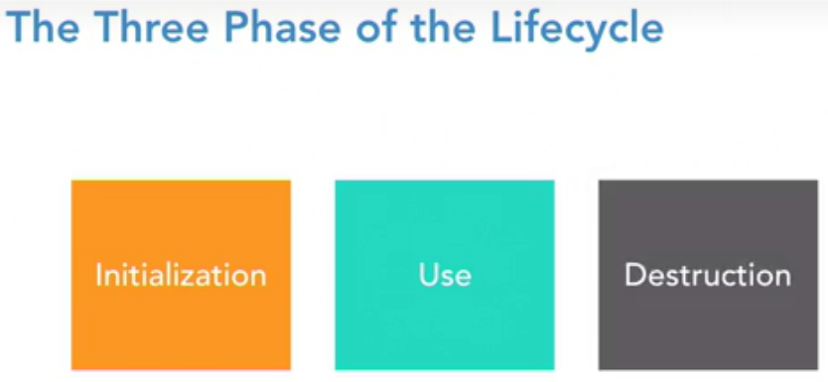

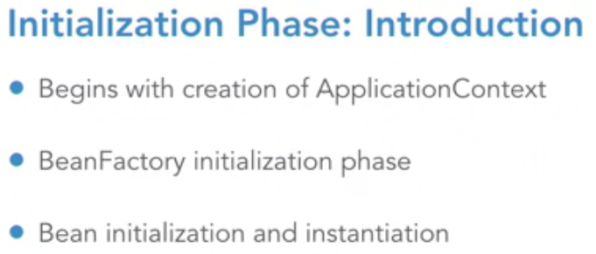

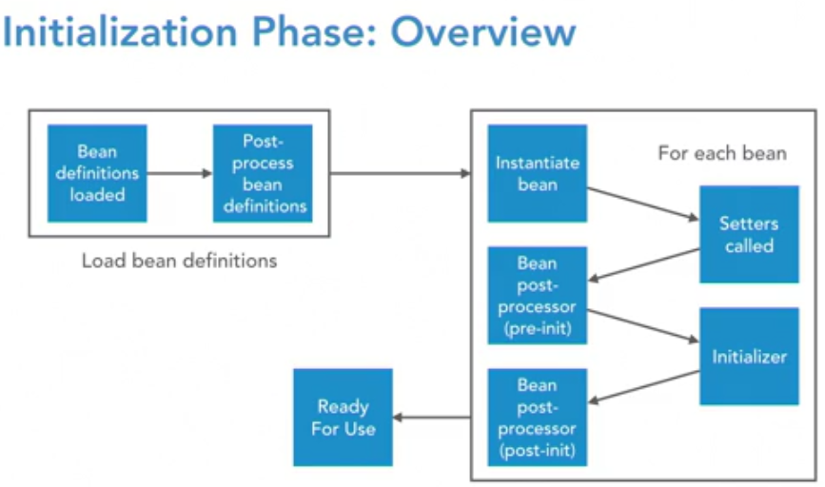

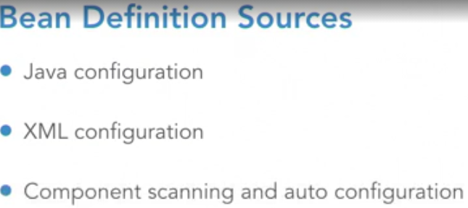

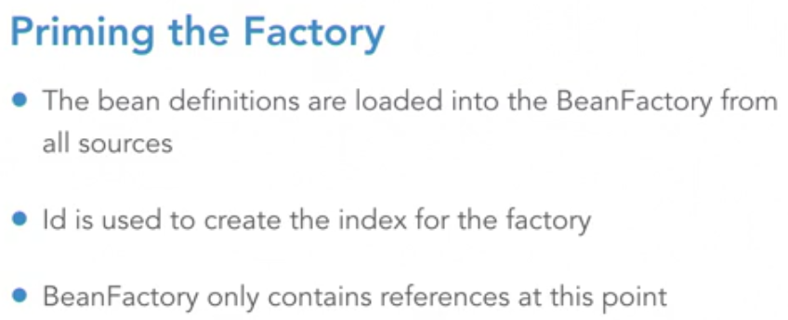

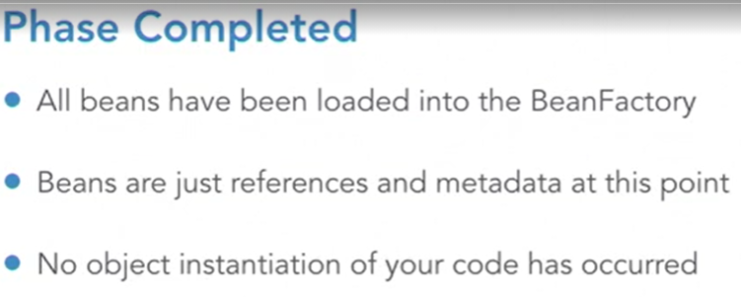

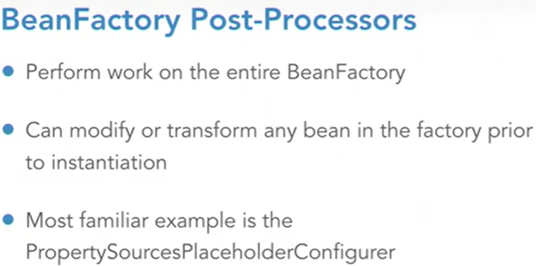

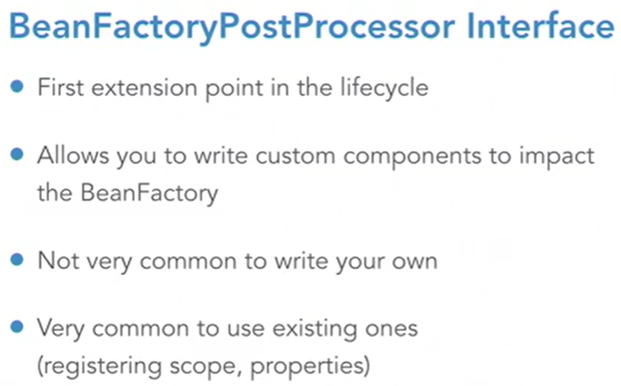

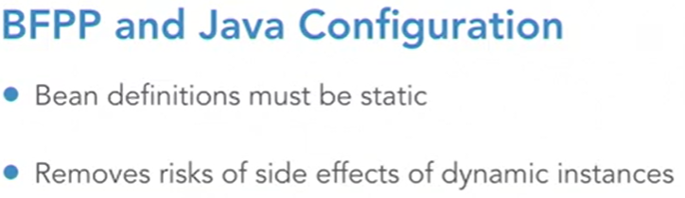

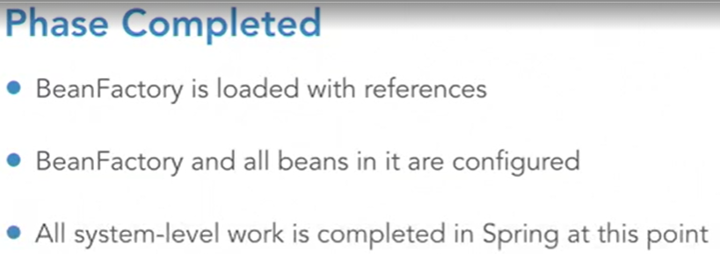

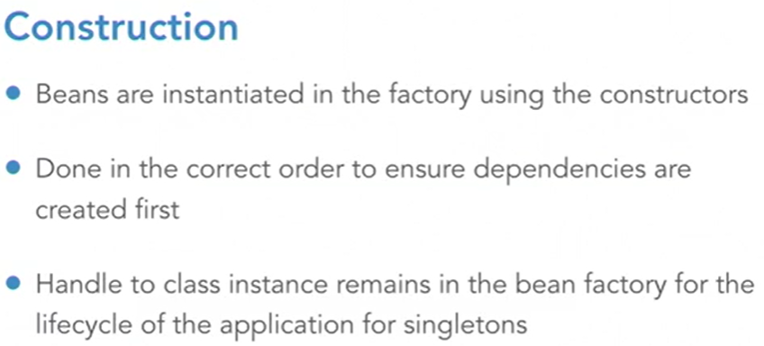

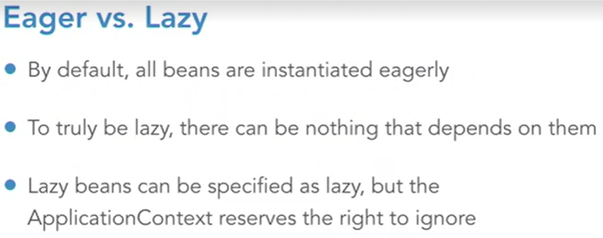

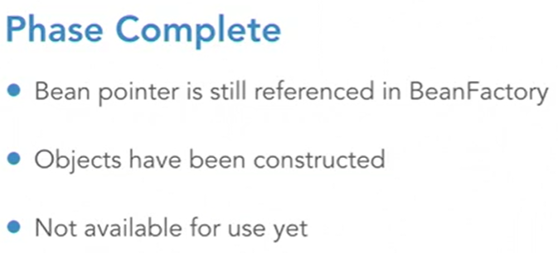

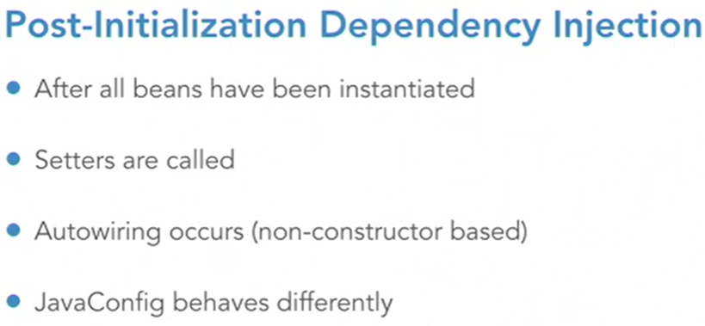

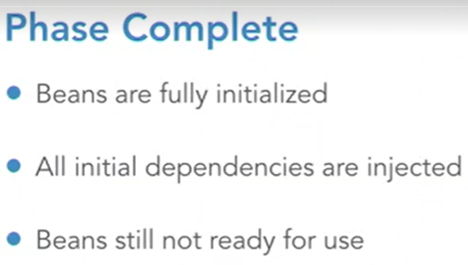

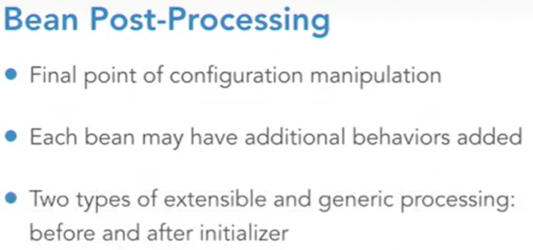

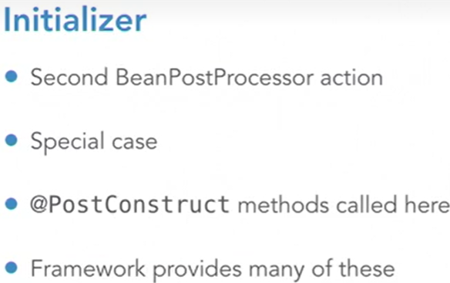

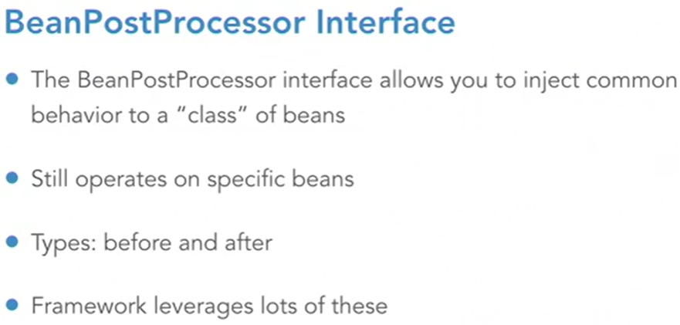

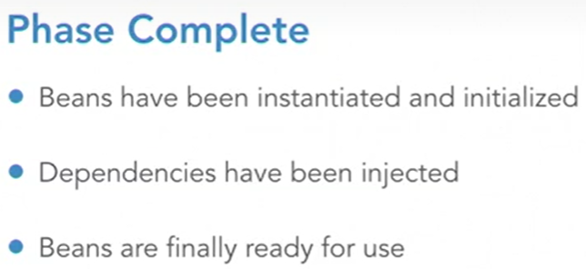

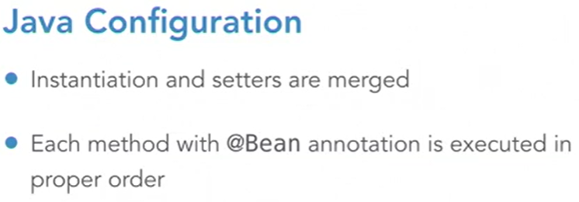

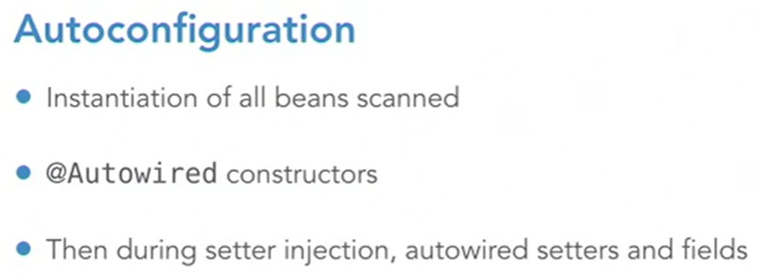

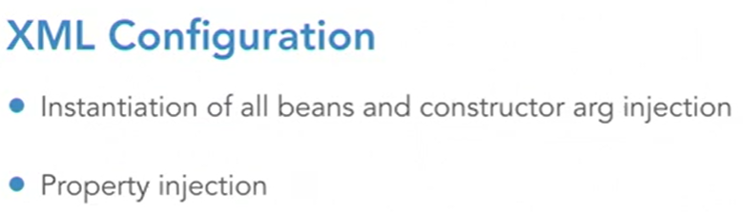

* Once all beans are initialized, configured, and instantiated, we enter the **Use** phase of the lifecycle.

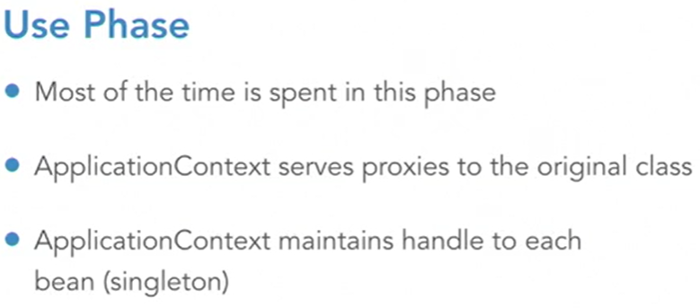

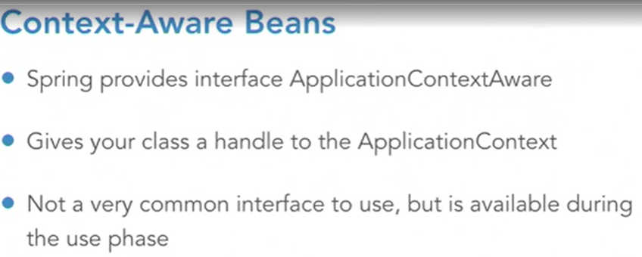

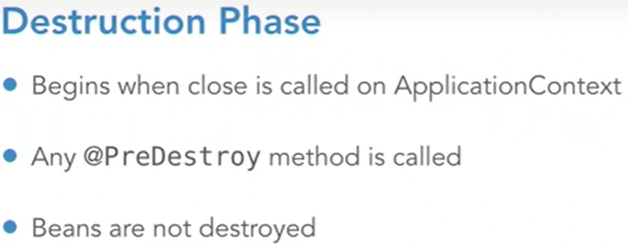

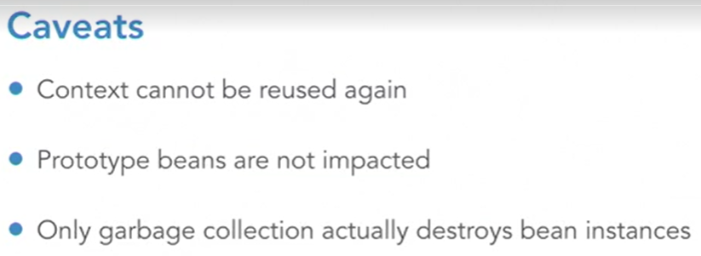

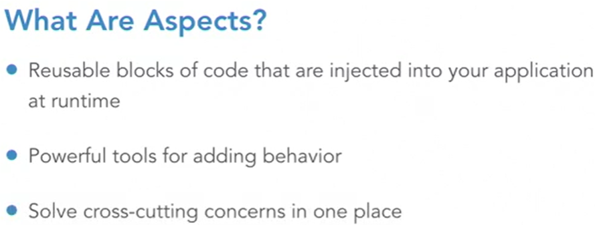

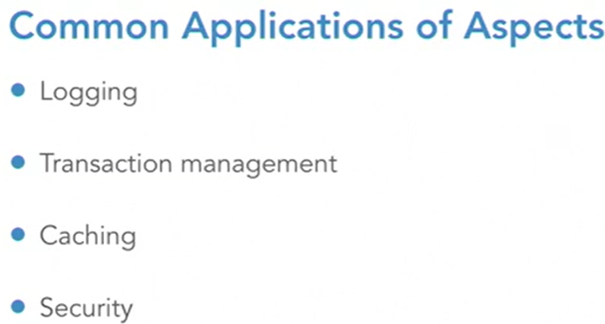

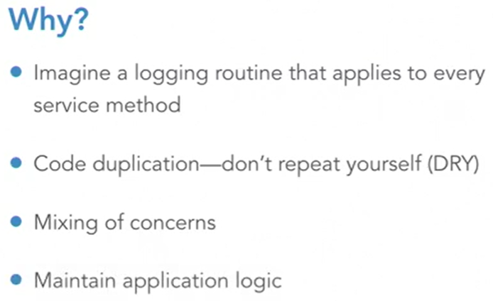

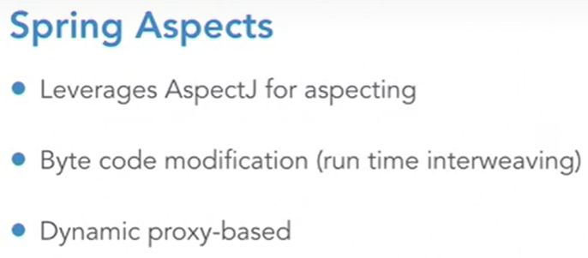

* Parts of a Spring Aspect:
  + **Join Point** – the spot in the execution of code where a cross-cutting concern can be applied.
  + **Pointcut** – a routine used as the selection criteria to select the Join Point to apply that crosscutting concern. The Join Point is the code, the Pointcut is what selects the code.
  + **Advice** – the code applied to the Join Point when selected by the Pointcut. It applies the crosscutting concern logic.
  + **Aspect**  - the entire package.

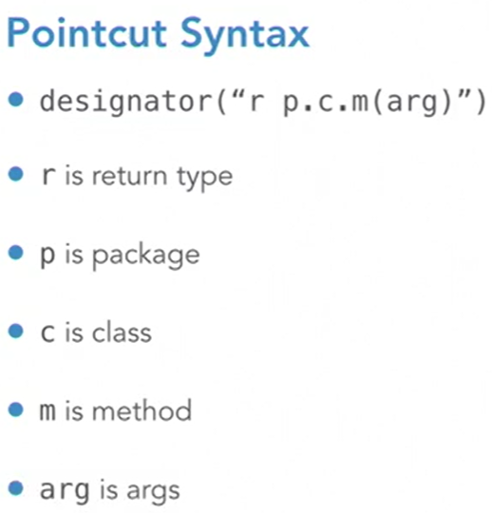

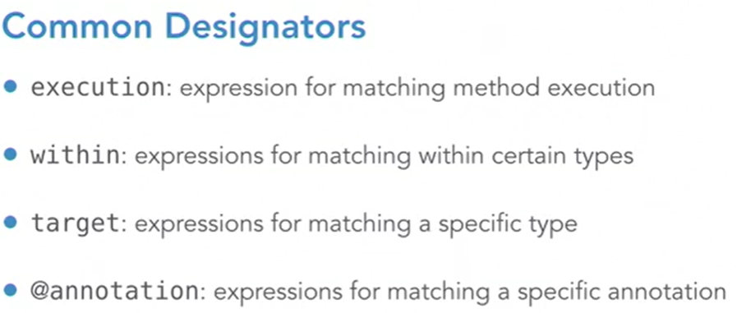

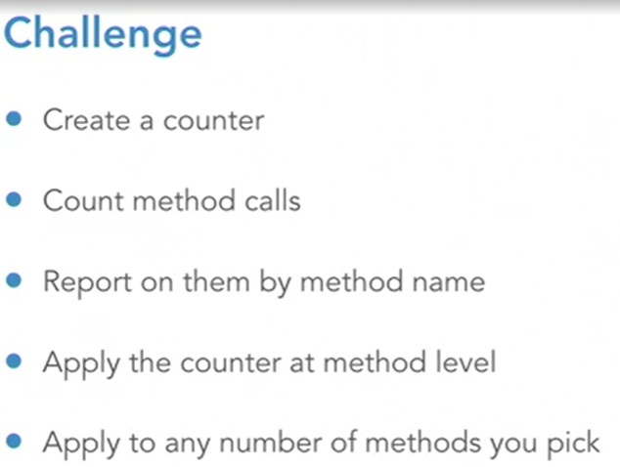

*************************************************************************************

**CREATING YOUR FIRST SPRING BOOT MICROSERVICE**

*************************************************************************************

* To user **Spring JPA**, we declare a Java interface class that extends from CrudRepository, where T is the domain type the repository manages, and ID is the type of the ID that the entity repository manages.

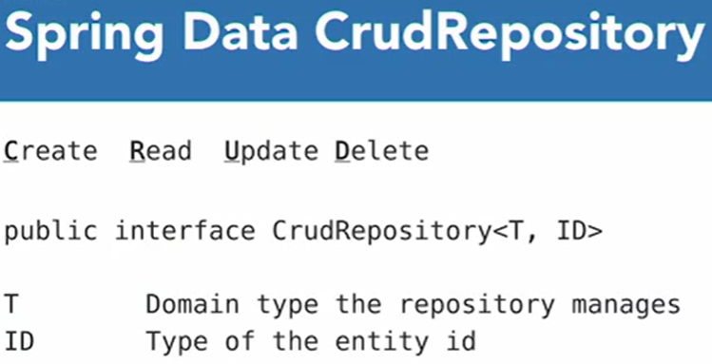

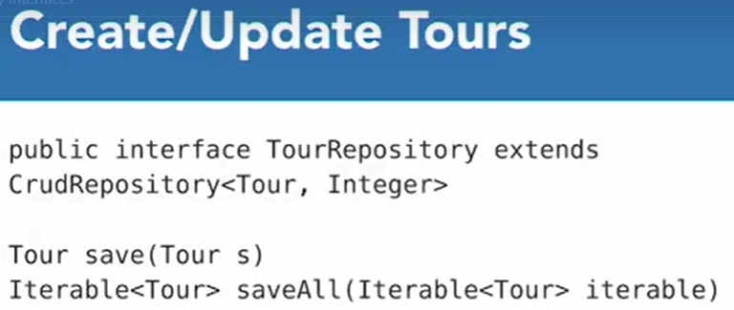

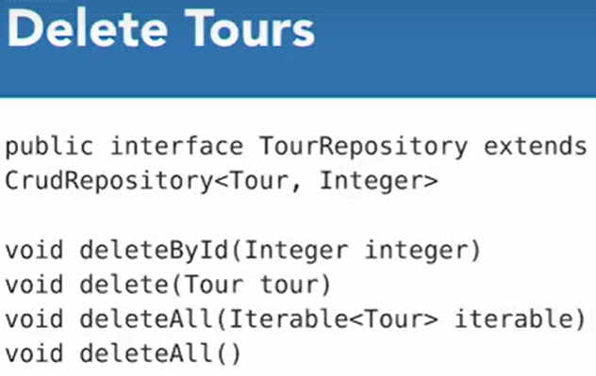

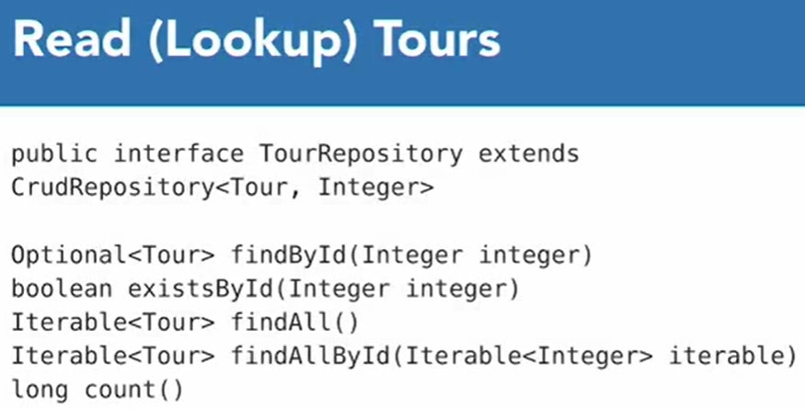

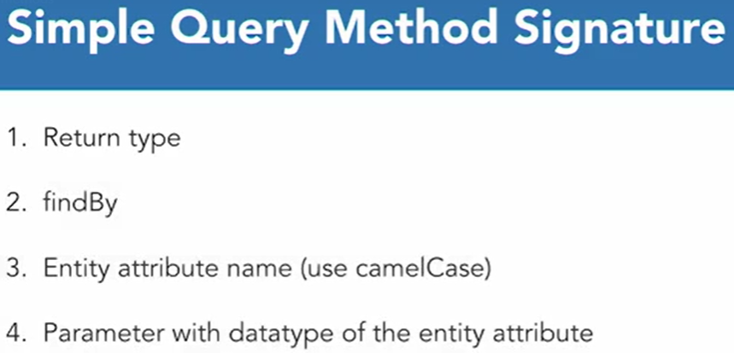

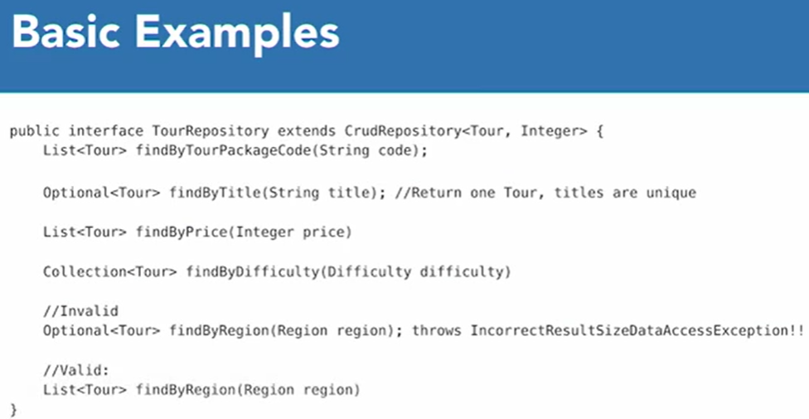

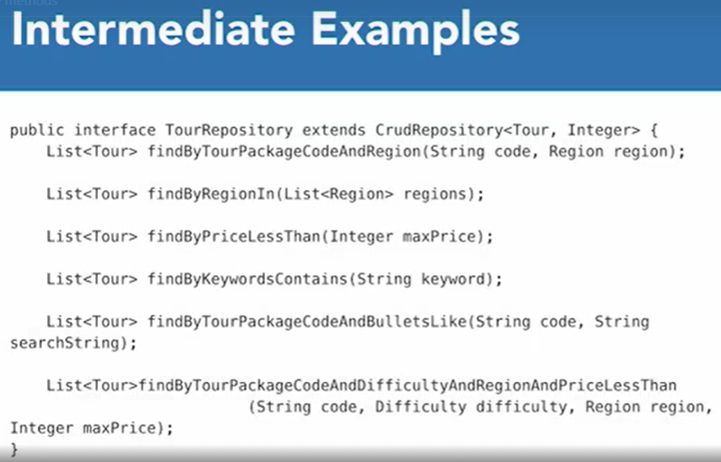

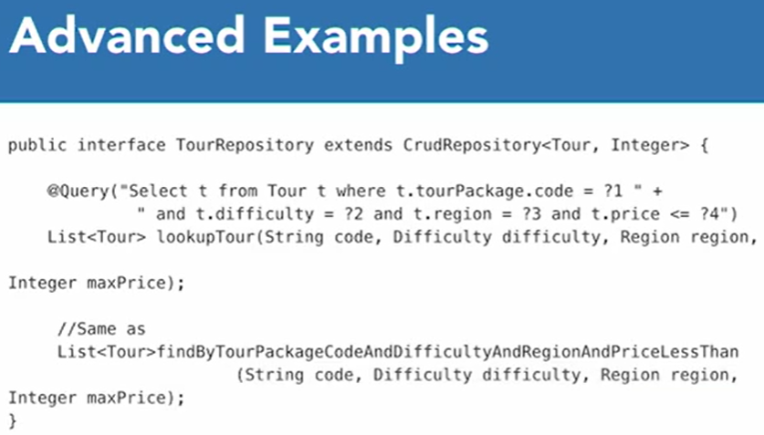

* A **RESTful API** should do more than expose resource endpoints over HTTP. It should also expose the API’s documentation and automatically provide navigation between resources. Hypermedia-driven APIs accomplish that.
* **Spring Data REST** employs the Hypermedia Application Language (HAL) standard to associate resource objects to one another.
* Every entity that Spring Data REST exposes also creates a */search* endpoint.
* **Paging** and **Sorting** features can be added to the API by extending the repository class that will use the features from *PagingAndSortingRepository*.
* We don’t want to allow the public to modify our database using CRUD calls through the API. There are two annotations to accomplish this: **@RestResource** is used to control access at the method level and **@RestRepositoryResource** to control access at the class level.

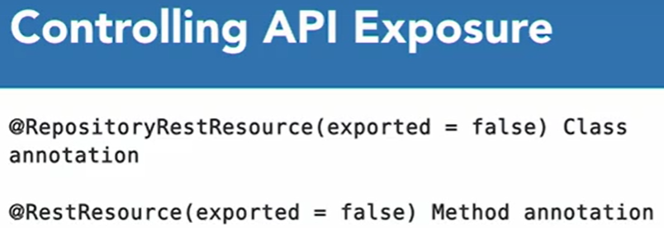

* **@RestRepositoryResource** can also be used to overfly the default endpoint name and setting it to something different.
* Spring Data REST provides its own documentation via the */profile* endpoint.
* **Spring Web MVC** can also be used to create RESTful APIs. A REST Controller class mediates between web requests and the internals of the application. It is responsible for directing requests to the appropriate services, and then sending the response back to the client. In Spring Data REST, the framework itself mediates between web requests and the Persistent Domain model.

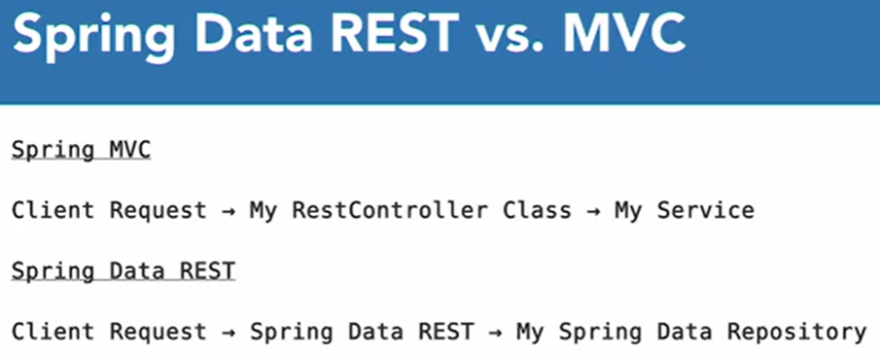

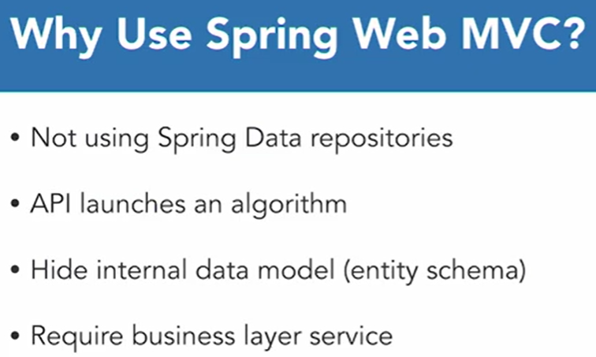

* **Using MongoDB**

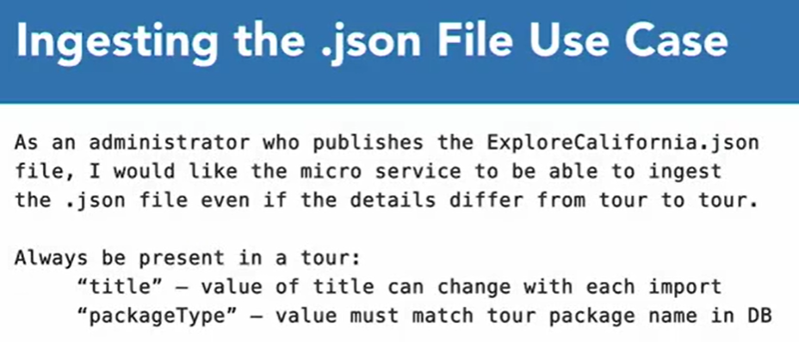

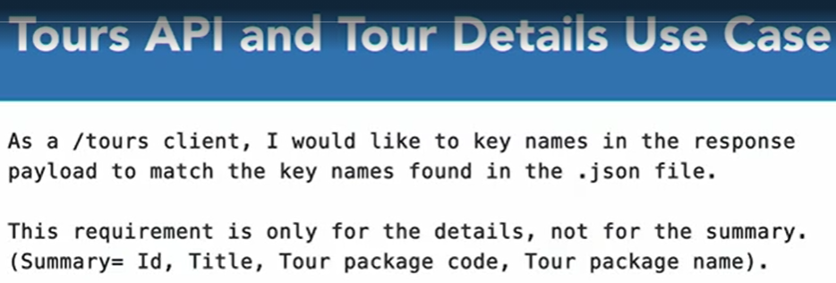

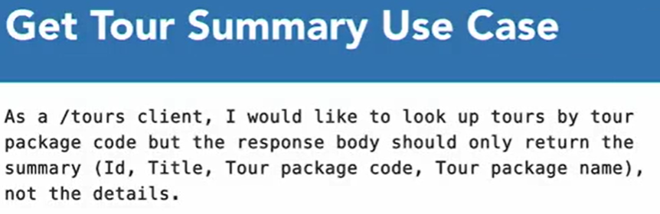

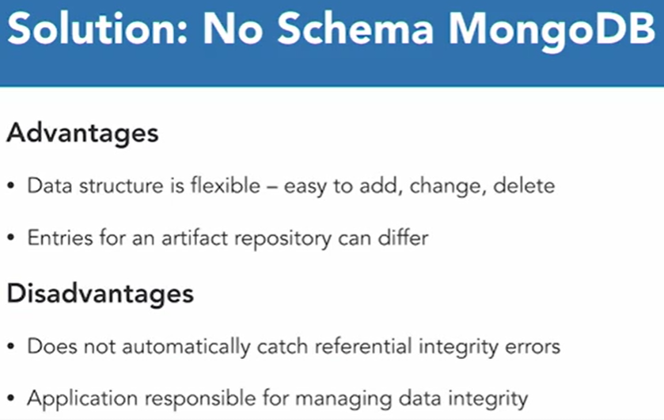

* **Spring Data MongoDB** follows the same patterns as Spring Data JPA. Code refactoring is required, but the structure of the microservice shouldn’t change.

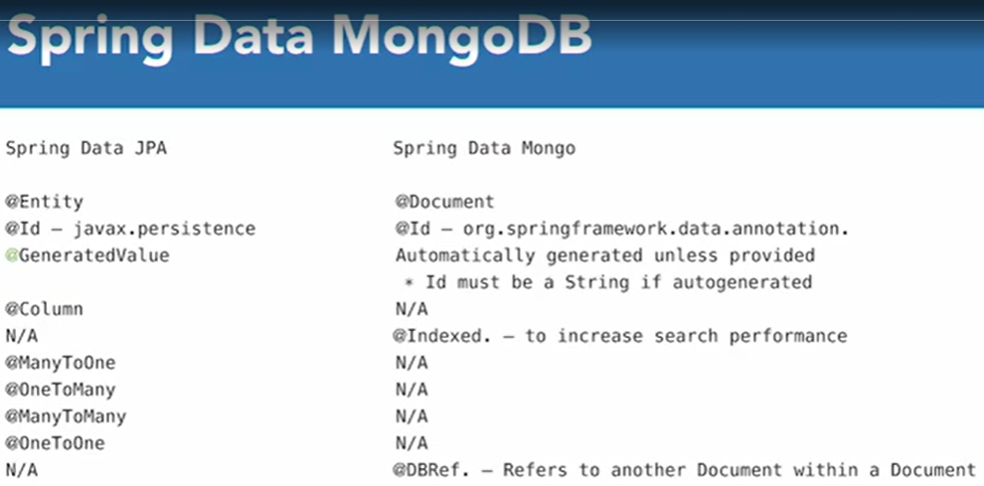

*************************************************************************************

**EXTENDING, SECURING, AND DOCKERIZING SPRING BOOT MICROSERVICES**

*************************************************************************************

* Adding the **@Transactional** annotation allows the services to behave transactionally so they can rollback in case anything fails.
* Don’t use *Spring-Boot-Starter-Parent* version 2.0.1 because it throws errors. Use 2.2.0 instead.
* In JAVA, the important artifacts for Logging are:
  + **Logger** – responsible por capturing the events.
  + **Appender** – records the events.
  + **Layouts** – responsible for the appearance of the data in the log entry.
* To use the HATOAS package make sure that the *Spring-Boot-Starter-Parent* version is 2.1.0 because the 2.0.1 throws errors when building and running the project.
* The setup of the Appenders and Layout is done in a file called *logback.xml*, which is located in the Resources folder.
* An **Integration Test** will invoke not just the class but also its underlying dependencies, while a **Unit Test** will test a class in isolation, testing only the code in the class and not its dependencies.
* If we have a test for a Service class component that is auto-wired with a Repository class, **Mockito** is a tool that can help us to test only the Service components, leaving the Repositories out of the testing.
* A cool feature of Spring Boot is the ability to invoke an application controller’s API in a real servlet environment without invoking the dependencies. Unlike other unit test that invoke Java Methods, this will invoke the URL. The Service class component is mocked out.
* *@MockBean* forces the Spring context to auto wire the Controller class components with a mock version of the Service class component, instead of the real version.
* RESTful APIs are stateless, so they don’t have any awareness between invocations. A common way of obtaining a session in a RESTful API is to invoke an API to authenticate and then return to the client a special encoded string (Token). Then, subsequent client requests add the token to the HTTP header.
* **JSON Web Tokens (JWT)** are encrypted data packets that have the following structure: *Header.Payload.Signature*. The Header has the type, which is a JWT and it also has the hashing algorithm. The Payload has the subject of the token, its expiration, and any application-specific key-value pairs separated by the colon. The Payload includes information about the principle (username and roles). The Signature has the hash value of the Header and Payload that is calculated with a secret string on the application.
* *JwtTokenProvider* encapsulates all the creation and coding of the tokens, while *JwtTokenFilter* is a Spring Web Filter. Web Filters are classes that execute before invoking the Controller or Spring Data REST Repository methods.
* **Flyway** is a database migration tool that controls triggering of version database migration scripts. It will know if a database script has already been run on the database.

*************************************************************************************

**SPRING: SPRING MVC**

*************************************************************************************

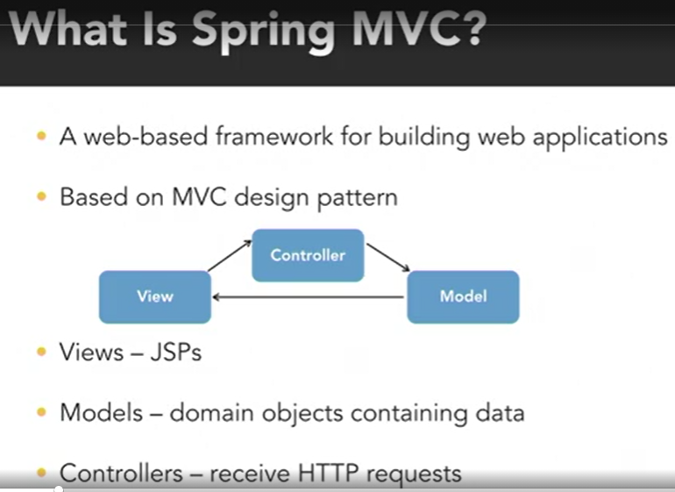

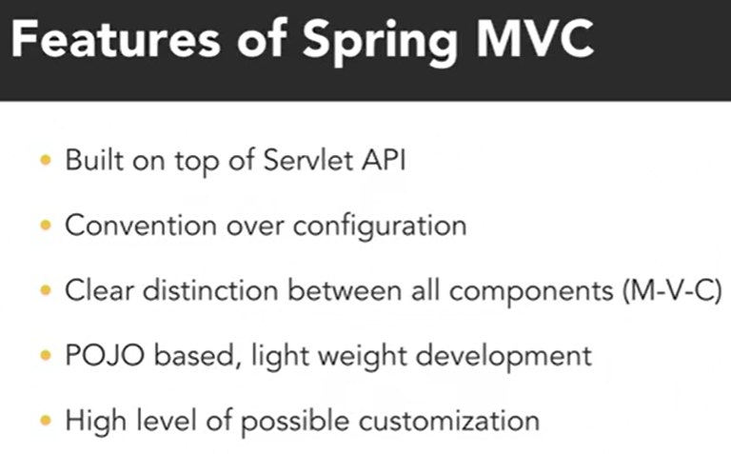

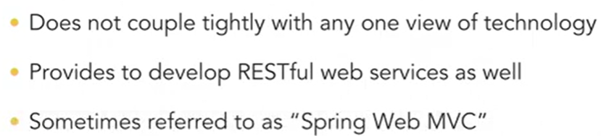

* When you have an incoming request from the client, it is intercepted by the *Dispatcher Servlet*. Every request is always uniquely identified by a *urlpattern*. This urlpattern is mapped to a filter and a controller dedicated to that request processing. The mapping resolution will be done by the Dispatcher Servlet by interacting with another special bean type called *Handler Mapping*. Once it does this resolution, it’ll delegate the control to the respective *Controller* component.
* All incoming requests are first intercepted by the Dispatcher Servlet, and based on who wants to go where, it will delegate the control to the respective Controller. The Controller is then free to call the rest of the Application Business Logic where it may talk to the database or any third-party service. Once the logic execution is completed, the flow comes back to the Controller and that’s the point where it decides to delegate the control to the View that will display the data. The request is picked by the Dispatcher Servlet and with the help of the *View Resolvers*, it will map the logical name provided by the Controller to the respective View Template.

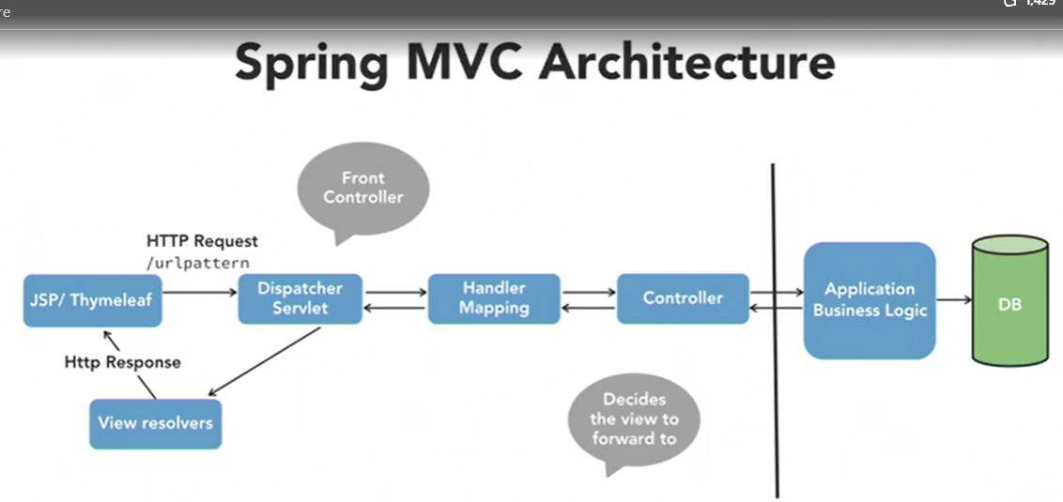

* To deploy a .war file with Tomcat, create a new Maven Build Configuration, that has this value in the “Goals” field: **clean install tomcat7:run-war**
* Important annotations and objects associated with Controllers:
  + **@RequestParam** – make sure that you receive request parameters from the incoming HTTP request inside the Controller.
  + **Model/ModelMap** – used to store the information for the views in the form of key/value parameters.
  + **ModelAndView** – basically the same as Model/ModelMap but this object can allow you to hold the name of the view and the data on the JSP in one single return type.
  + **@ModelAttribute** – facilitates data binding.
* Whenever you’re displaying pages and you have Model attributes attached to those elements, make sure that a default object with the default values is provided to the page, so it gets rendered correctly.

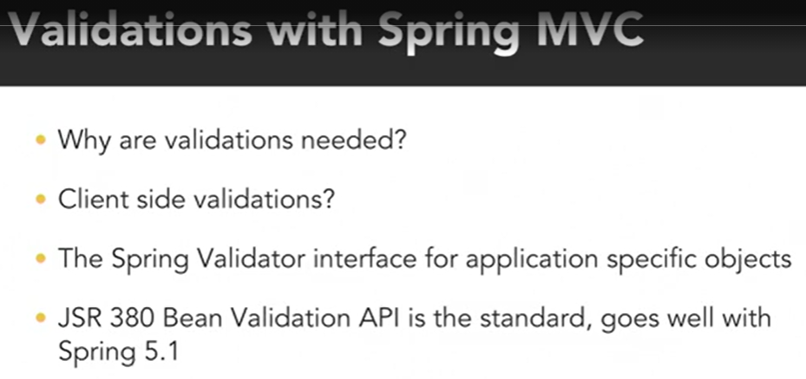

* The **@Valid** annotation needs to be used in the Controller so Spring knows that validations on the data will be carried on.
* *BindingResult* stores the errors when the validations fail.
* **Binders** extract and bind the request data to the Java model objects, but they convert Strings to complex data types that have been defined in the model.

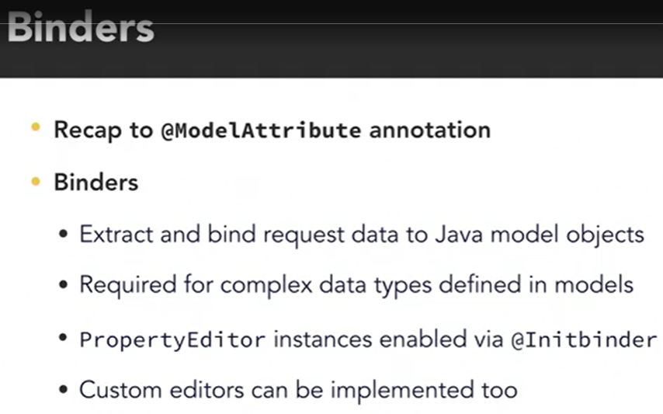

* **Convertors** extend Binders and provide one more way of customization.

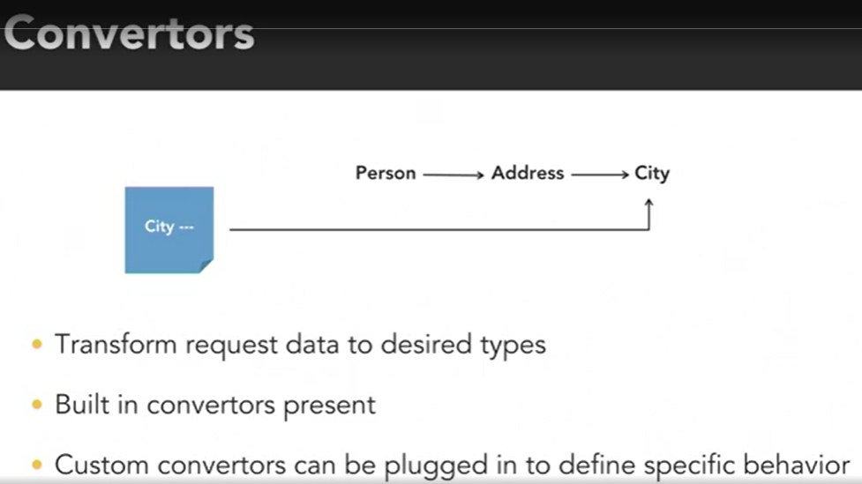

* The HandlerMapping may include pre- and post-processing components like **interceptors (filters)**.

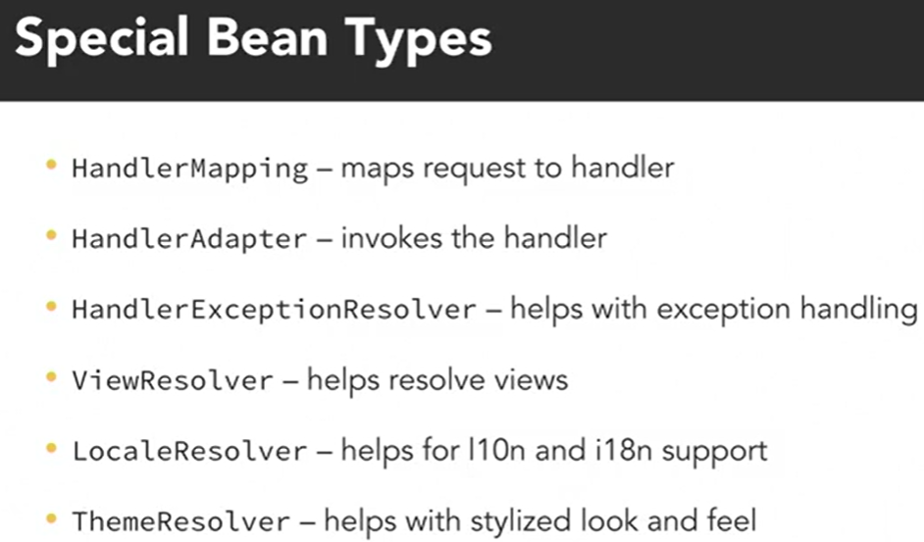

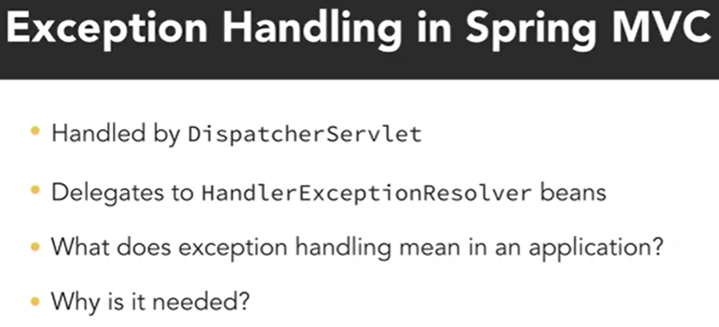

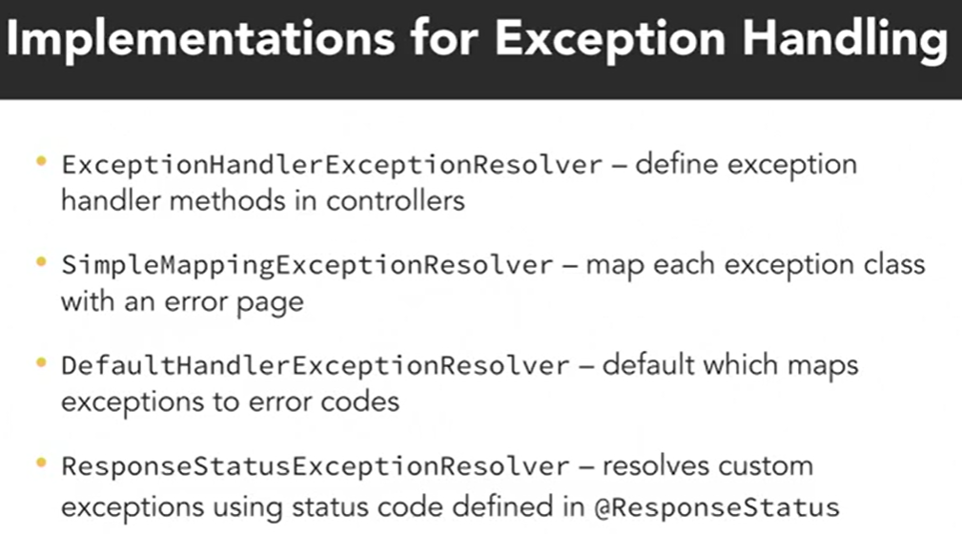

* An **Advice** is a term drawn from Spring Aspect Oriented Programming and it essentially means a piece of code, a piece of functionality.

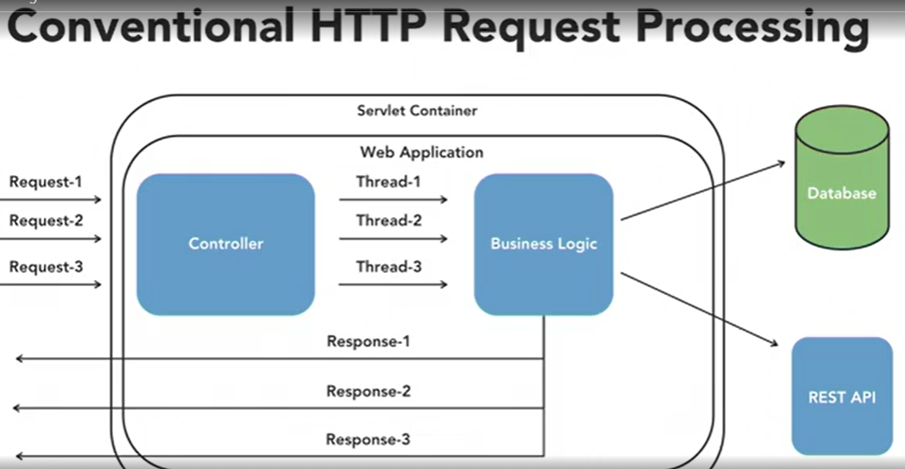

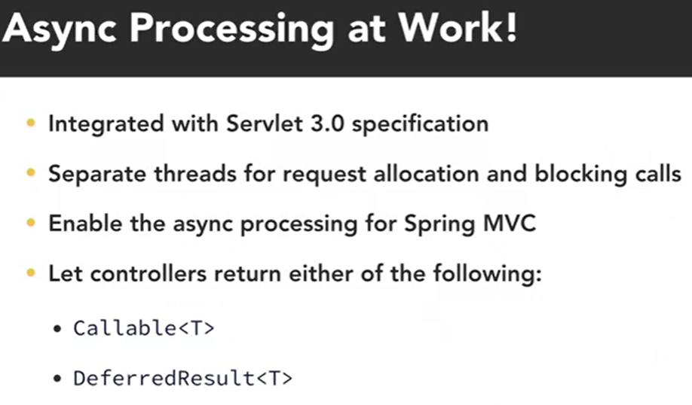

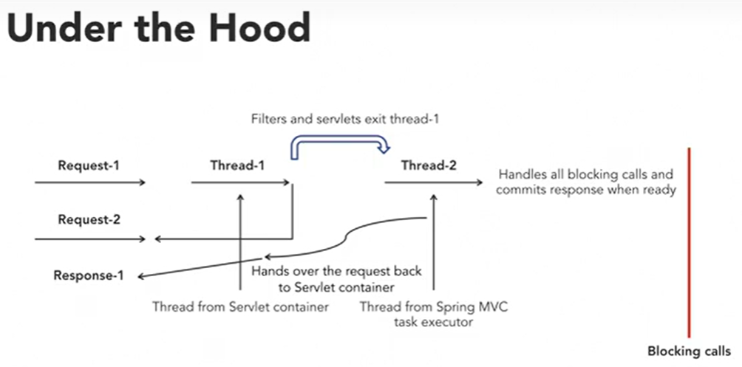

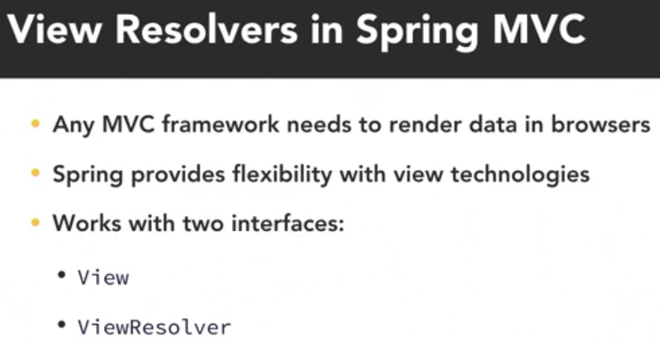

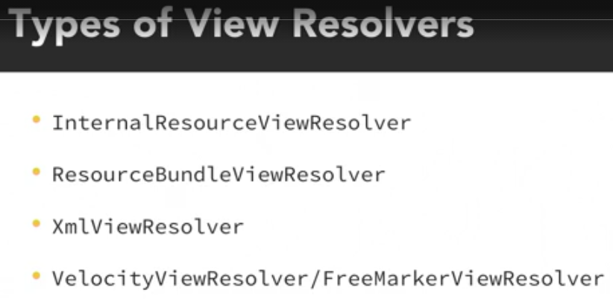

* Multiple View Resolvers can exist in a Spring Application, and you will be able to set an order on each of them, using a Set Order method available on the Resolver Object.

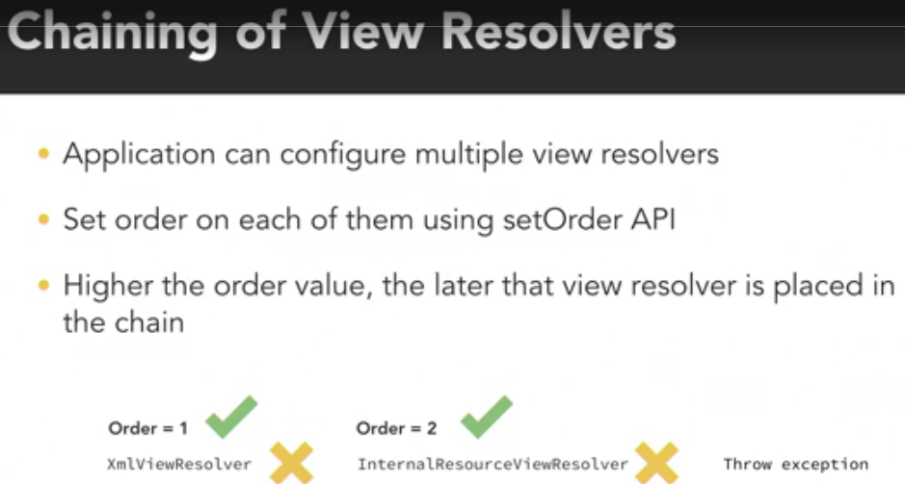

* Very common use cases for **Interceptors** are user authentication, setting up a session, or just locking some request data.
* **Interceptors** generally hold the piece of functionality which is the administrative part of the application.

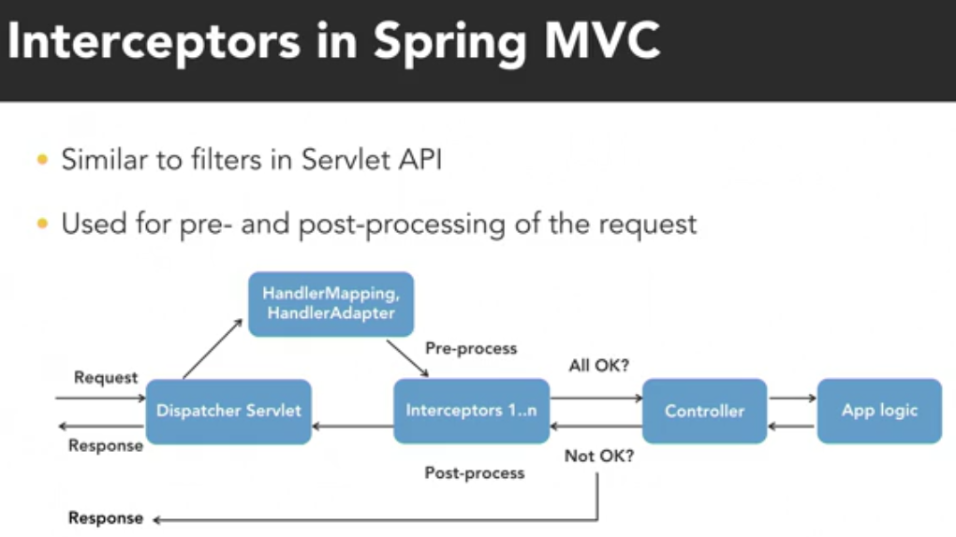

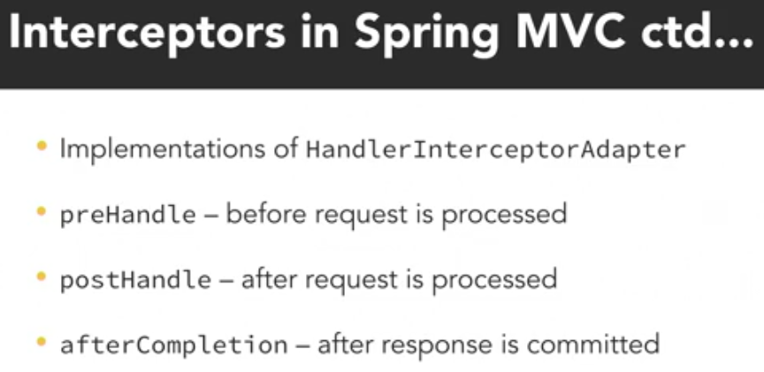

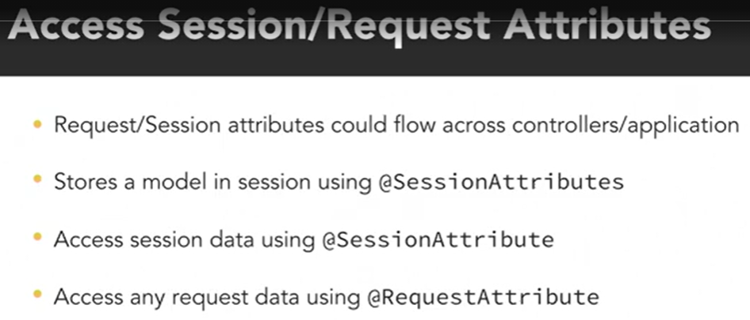

* A **Theme** is a collection of static resources (CSS files, images). They provide an enhanced look & feel to the end customers.

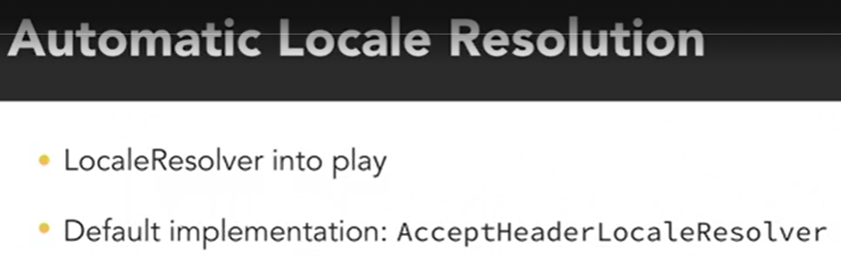

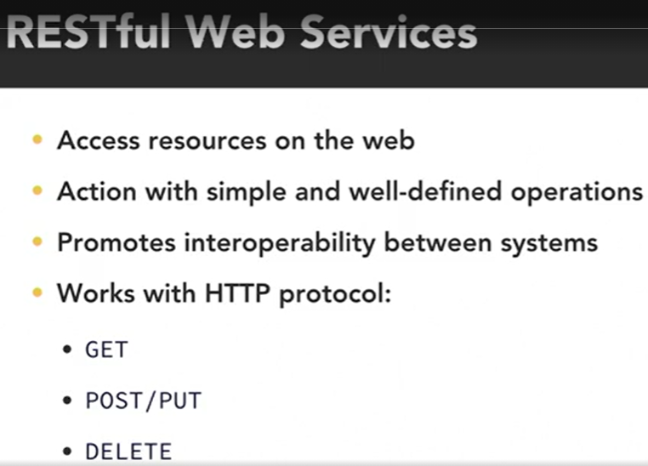

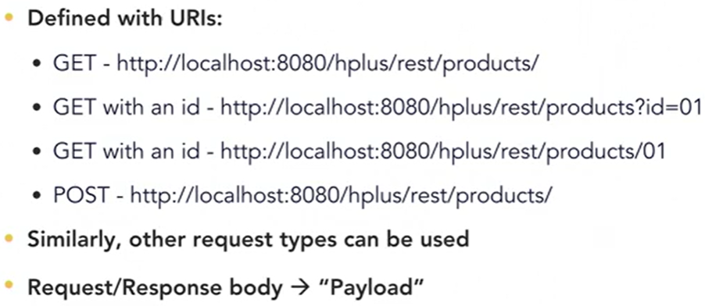

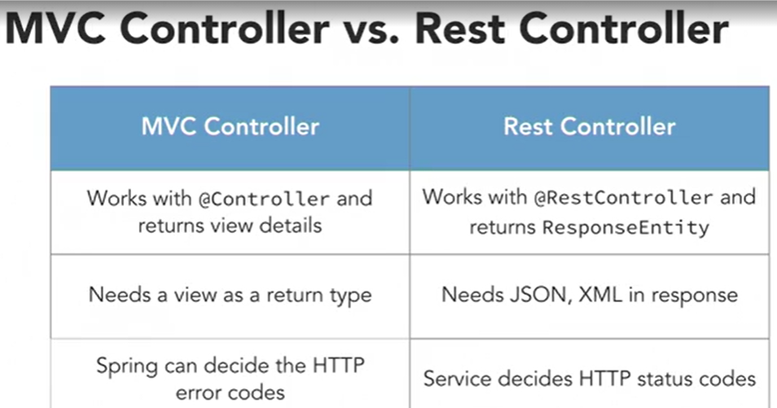

*************************************************************************************

**SPRING: SPRING DATA 2**

*************************************************************************************

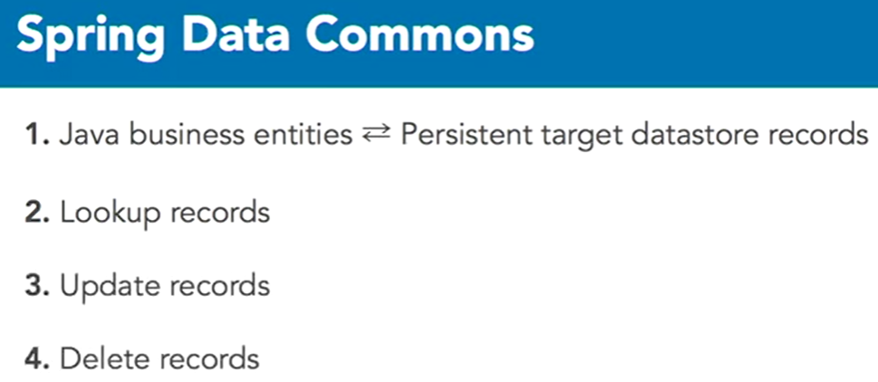

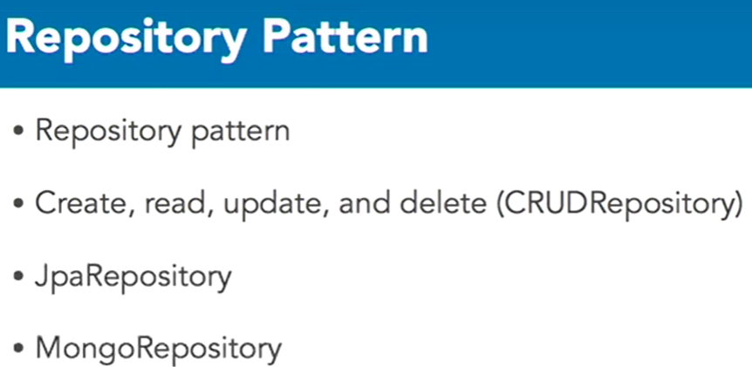

* With an ORM Framework, a developer declares metadata to associate Java classes and attributes to database tables and columns. The framework then handles the actual database interactions, so the code is abstracted away from the database.

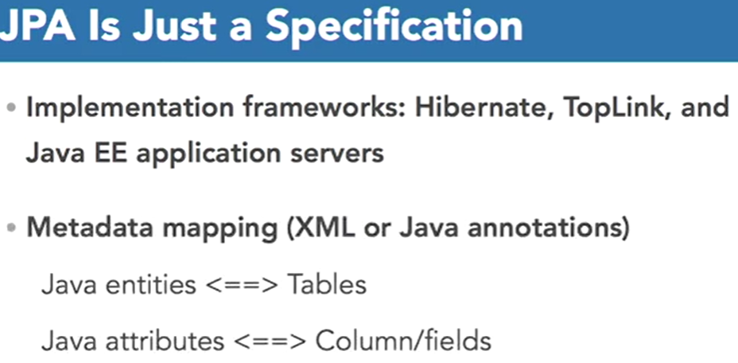

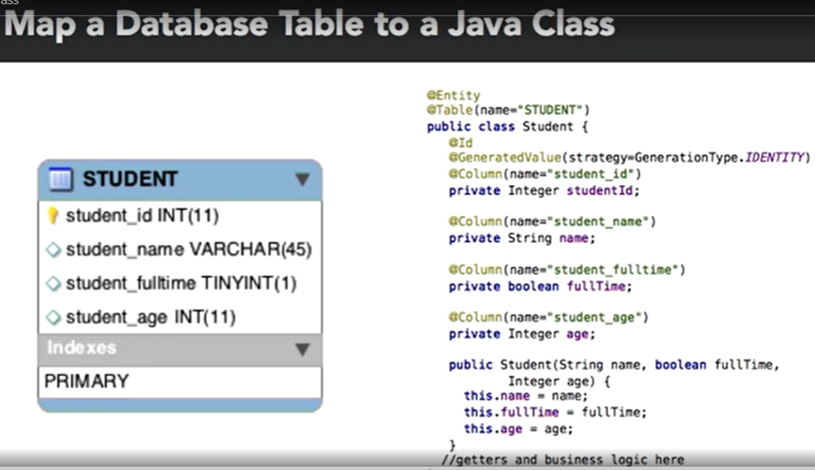

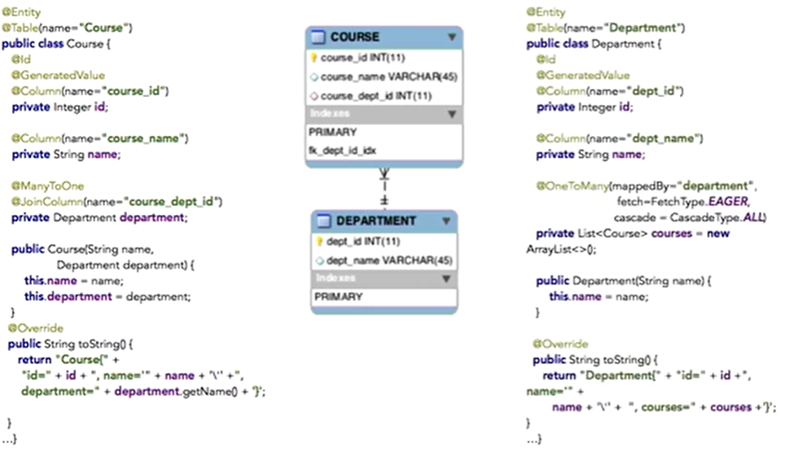

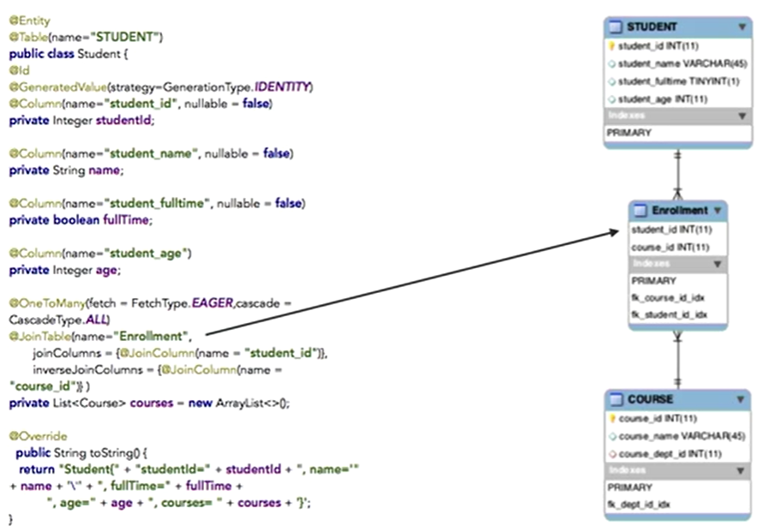

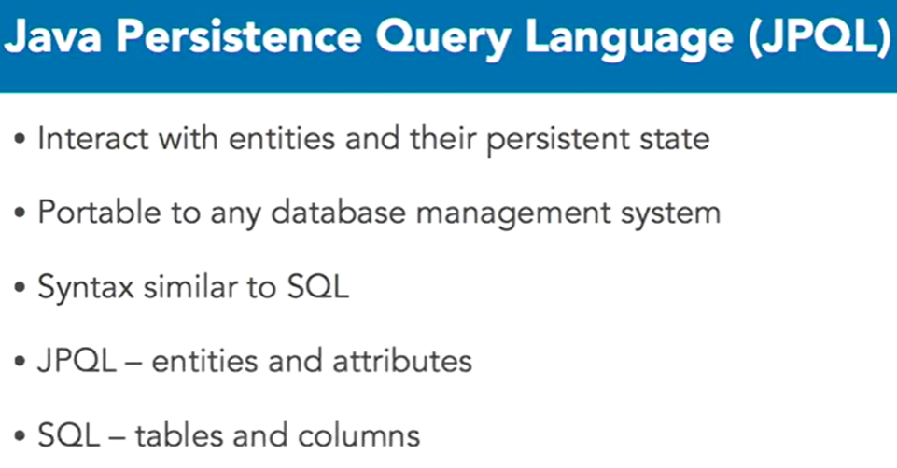

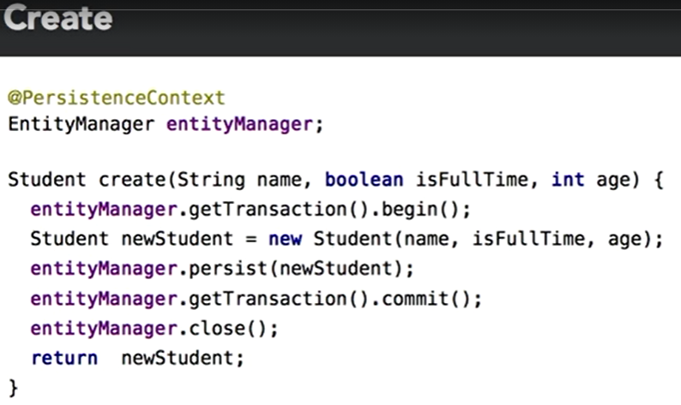

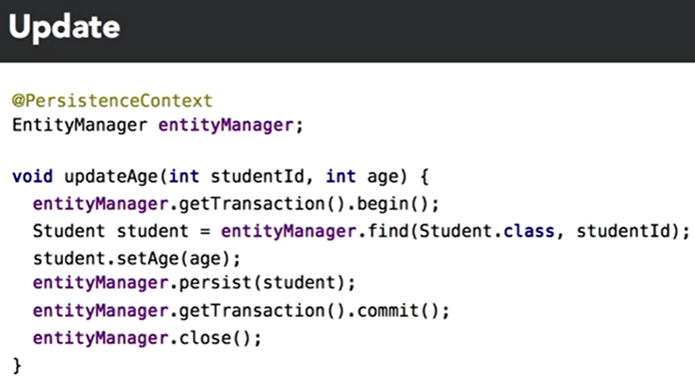

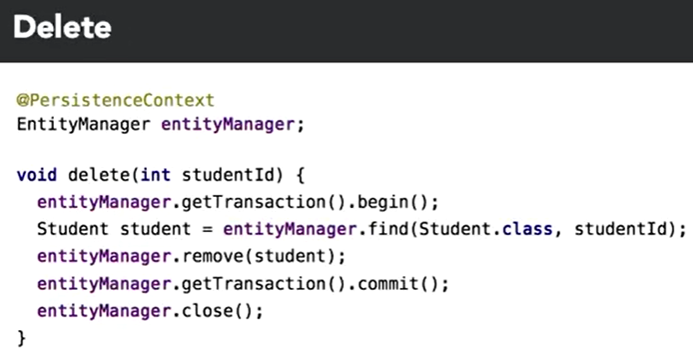

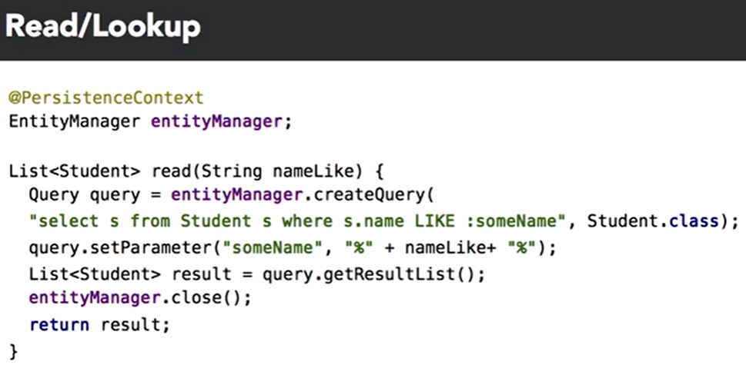

* **Spring Data JPA**

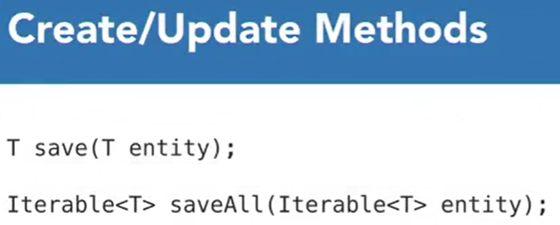

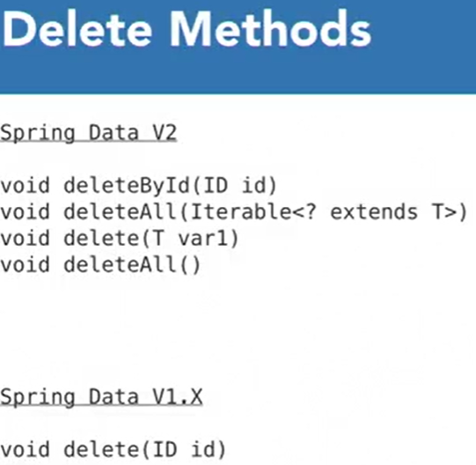

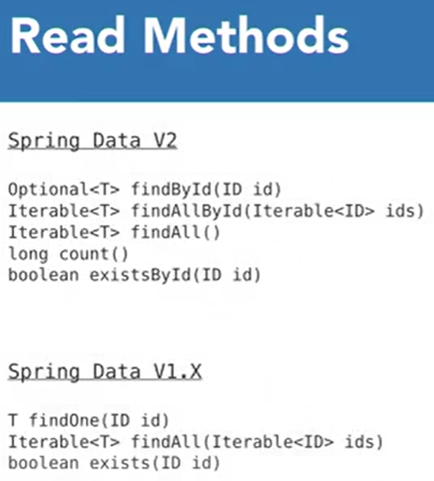

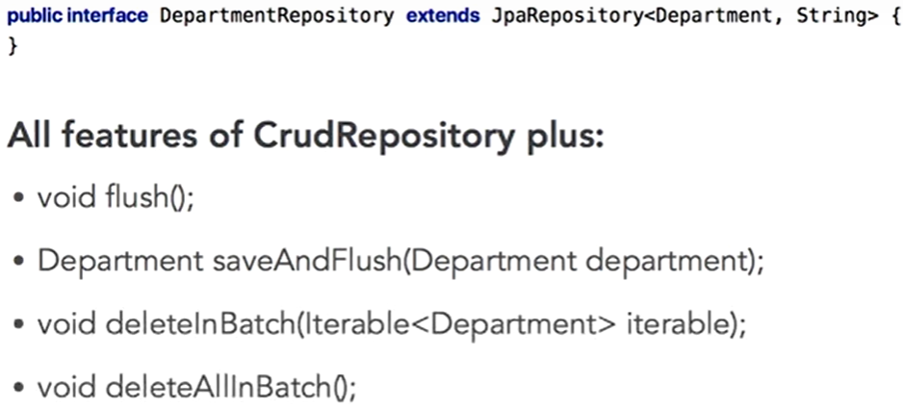

* There are cases where using **JPARepository** has benefits over CRUDRepository. If you really need to flush the data from the database you can just call the repository method rather than injecting the EntityManager factory to get the EntityManager instance. Second, it helps applications to access many types of data stores.

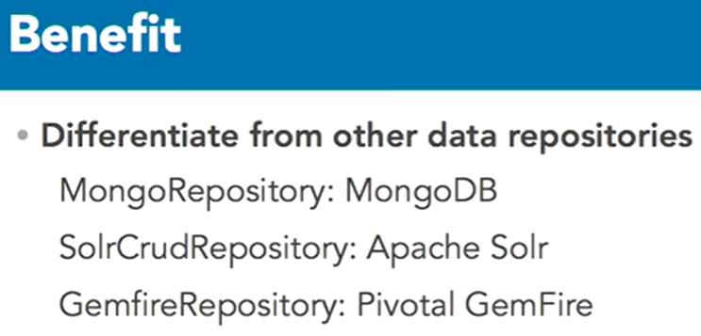

* We must follow the rules when declaring methods and correctly map the entity properties to the method signatures.

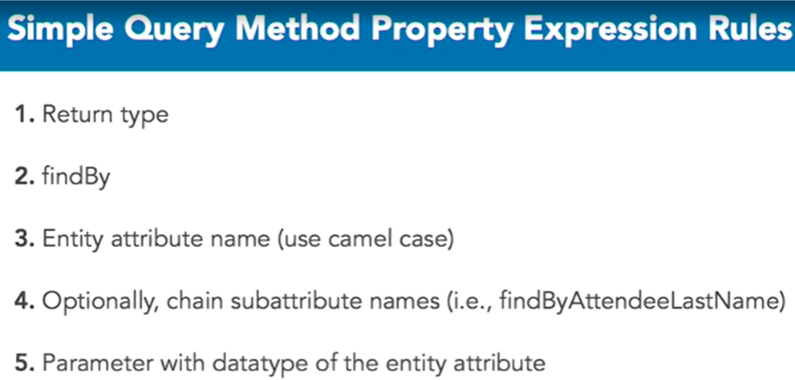

* Unlike regular SQL, syntax errors are found at startup and not runtime.
* Another way to declare a query method is by applying the **@Query** annotation. The contents of the annotation can be a source specific query language, like JPQL, or a query language native to the actual data source management system, like MySQL.

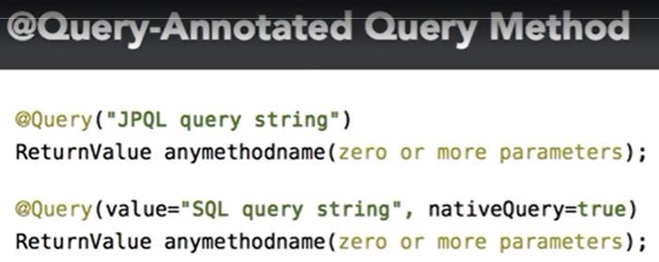

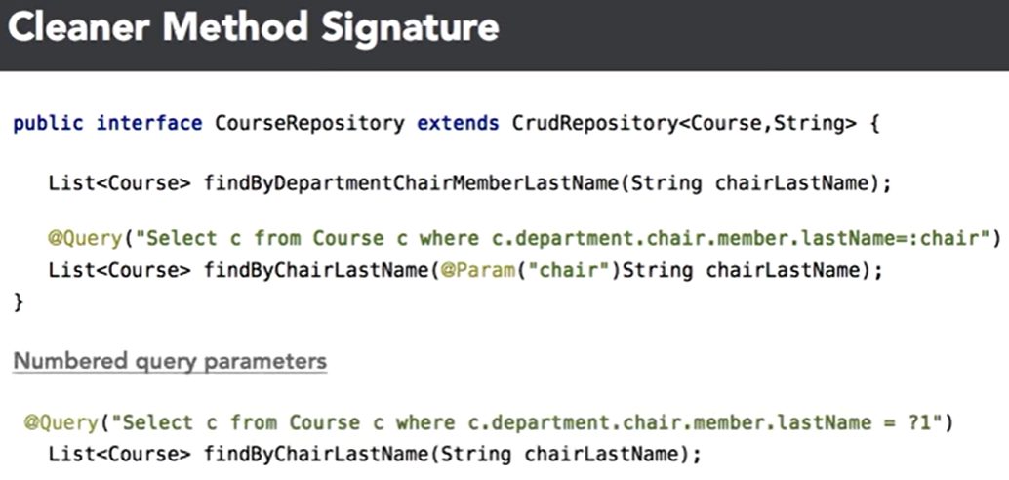

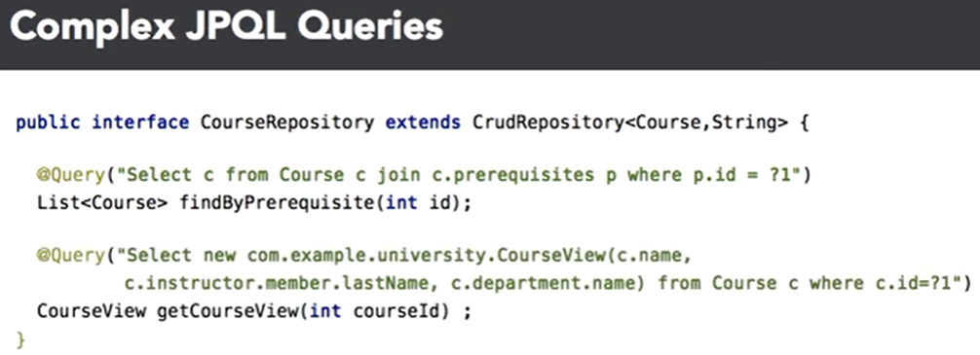

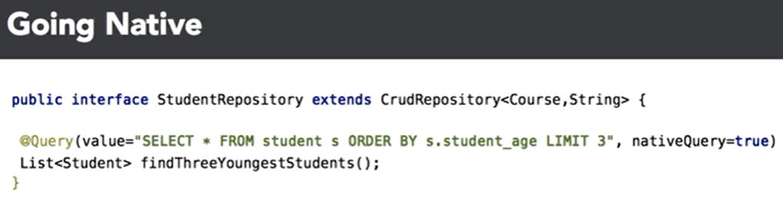

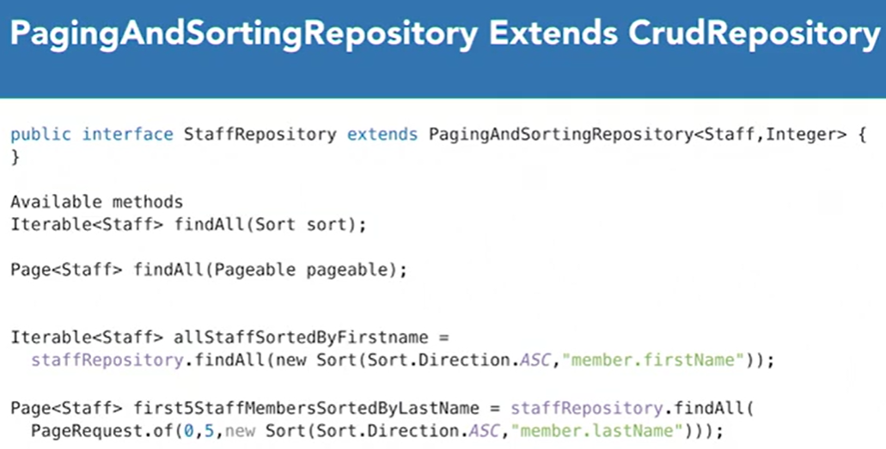

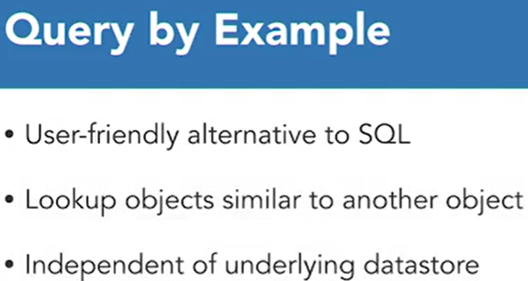

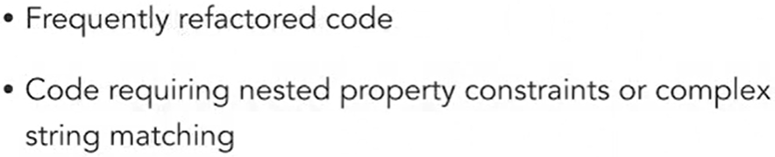

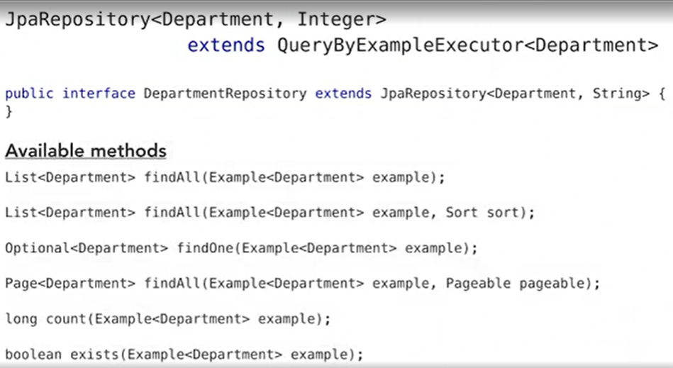

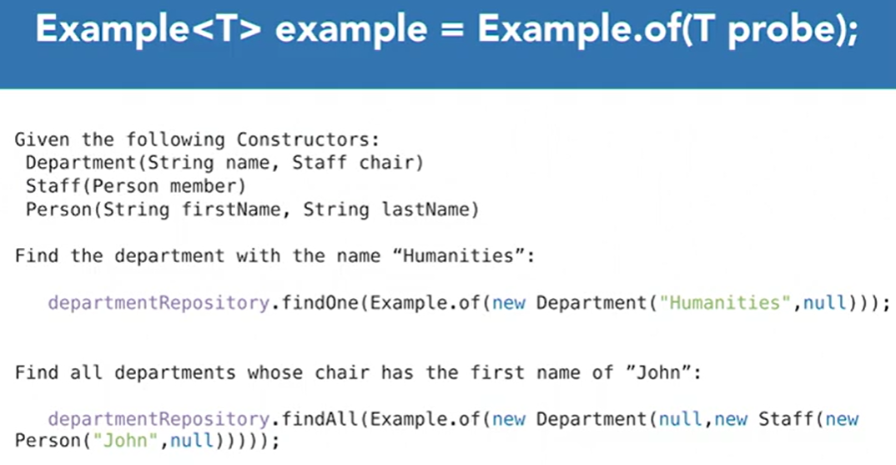

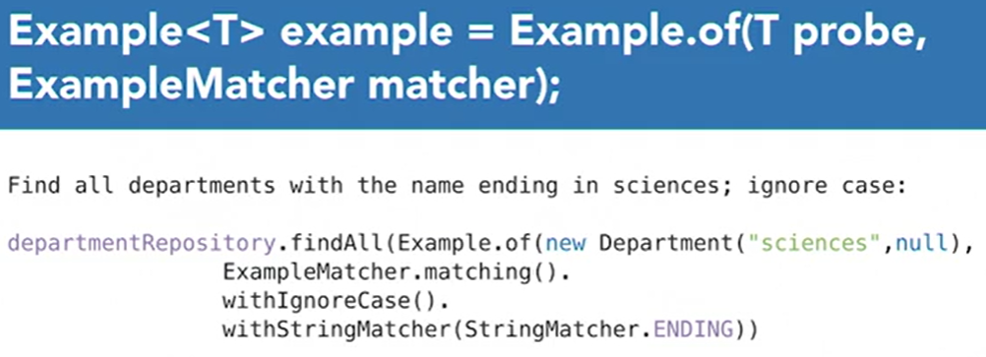

* **Optional** leverages the ability for optional return types in queries, thus avoiding null references.
* **JDBC Repositories** interact with relational databases but they don’t rely on JPA. JPA offers features such as lazy loading, caching, and dirty tracking. These features may be useful but they also can also make an application more complex than necessary. Lazy loading may trigger expensive SQL statements or unexpected exceptions, caching can hide recent updates to the database, and dirty tracking makes it difficult to locate the point of operation persistence. Spring Data JDBC bypasses all that in favor of a simpler model. SQL statements are issued when and only when you invoke a repository method and return a fully loaded object.
* **Spring Data JDBC** has drawbacks too. It doesn’t support many-to-many or many-to-one mappings.
* Spring Boot 2.0 introduced a new technology to provide non-blocking IO, called the **Reactive Stack**. It leverages multi-core processors to handle several concurrent connections. The original *Servlet Stack* provides synchronous blocking IO with one request per thread. Spring Data now provides reactive repository interfaces that interact with non-blocking data sources such as Mongo, Cassandra, Redis, and Couchbase.
* The return types of Reactive Repositories are either **Mono** or **Flux**. Mono is an asynchronous publisher of zero or one result, while a Flux is a publisher of an asynchronous sequence of zero to any number of results.
* *Spring GemFire* is a project that makes it easier to build scalable Spring-enabled distributed data management applications that use GemFire, which is an in-memory data grid for real-time high performant applications.
* *Spring Data Key-Value* provides infrastructure that implements Spring Data repositories on top of a key-value based in-memory data store. It abstracts away from a particular key-value data source such as Redis, which is an in-memory data structure store that can be used as a database, cache, and message broker.
* *Spring Data LDAP*, in which the applications used the Lightweight Directory Access Protocol to access object directory mapping data sources.
* *Spring Data for Apache Cassandra* offers an easier entry into the paradigm shift away from relational databases. Cassandra is a distributed database management system designed to handle large amounts of data across many servers. It supports data center spanning clusters with asynchronous replication.
* *Spring Data for Apache Solr* provides easy configuration and access to the Apache Solr search server. Solr is a full-text search server that uses Lucene search library as its core for full-text indexing and search via RESTful JSON APIs. It provides distributed search and index replication that is designed to be scalable and fault tolerant.
* **Spring Data REST** is a module for exposing Spring Data repositories as hypermedia-driven RESTful web services.

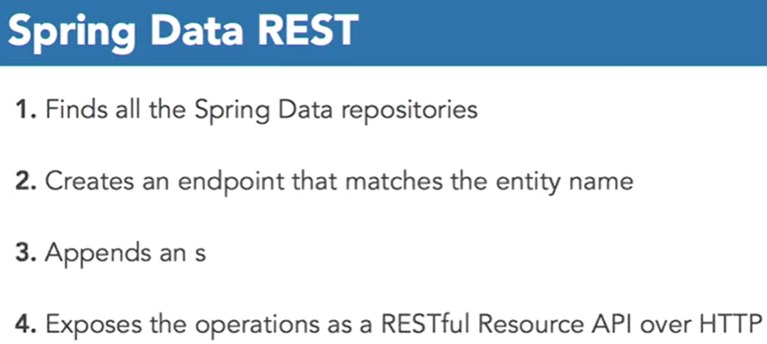

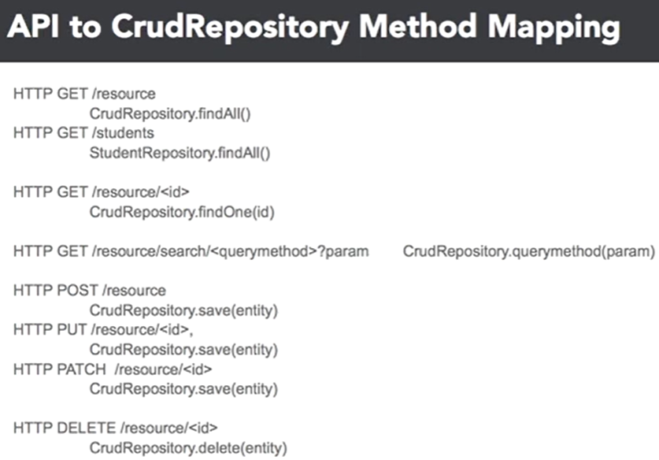

* Spring Data Commons query methods are static. Filtering by multiple fields requires several query methods covering all possible combinations.

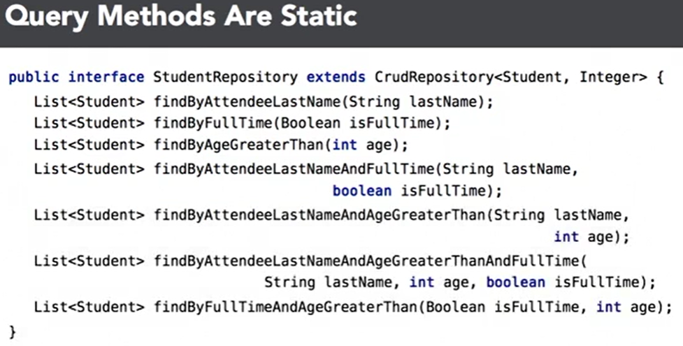

* **Querydsl** is a dynamic search criteria framework, and works with various data sources.

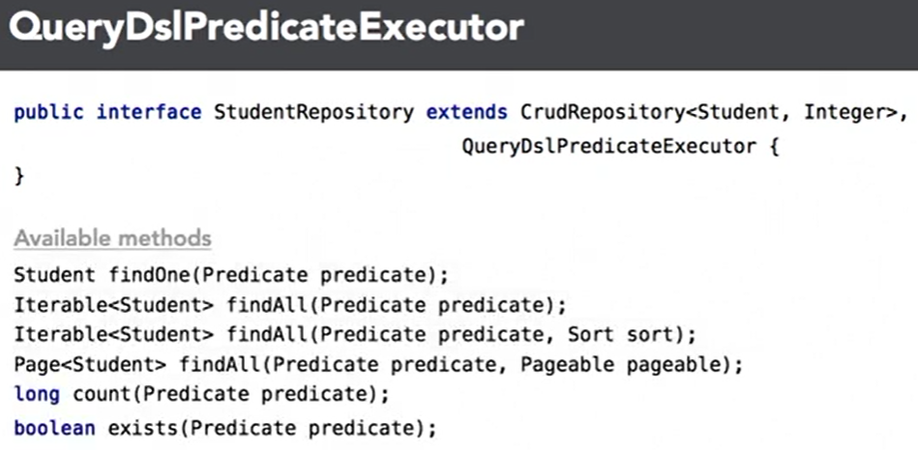

* The Querydsl annotation processor generates what are called QClasses from entities. QClasses are search criteria helpers to create what are called Boolean expressions, the building blocks of predicates.

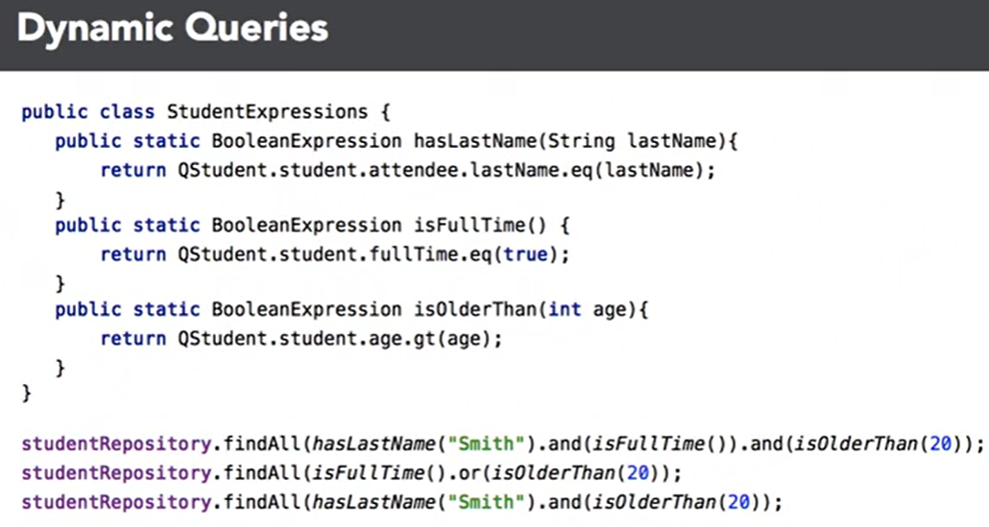

* There are two ways to wire up **Spring Data Auditing**: one way is to decorate your own entity attributes with predefined annotations. The other way is not to touch the entity attributes, but to implement the Auditable interface and extend from AbstractAuditable base class instead.

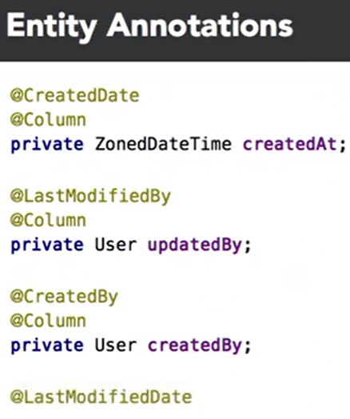

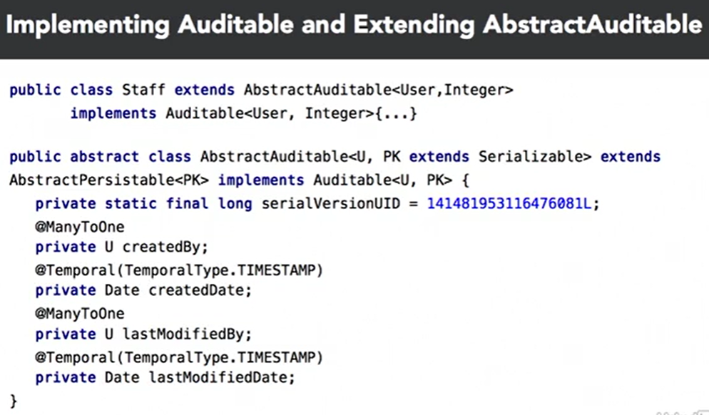

* Either way, you need to pull the user off of the session principle and inject it into the entity. This is done by implementing the AuditorAware service provider interface.

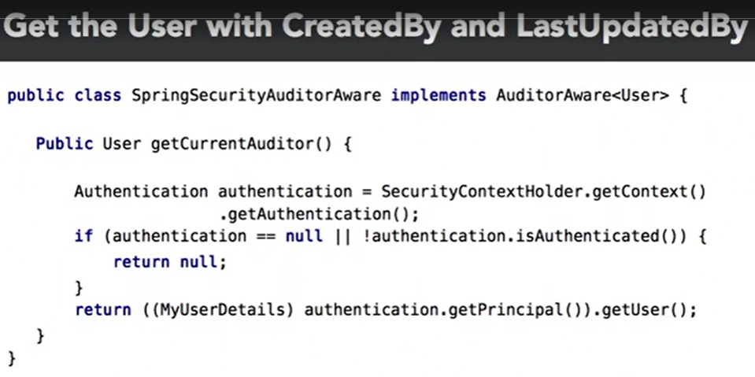

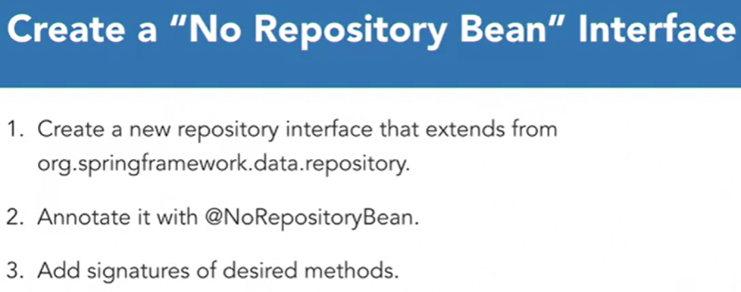

*************************************************************************************

**SPRING: SPRING SECURITY**

*************************************************************************************

* Security should be tackled in a layered fashion. This pattern provides distinct focus areas to secure, monitor, and tune. Most often, the focus in the layered model starts at the lowest level and that is the physical hardware.

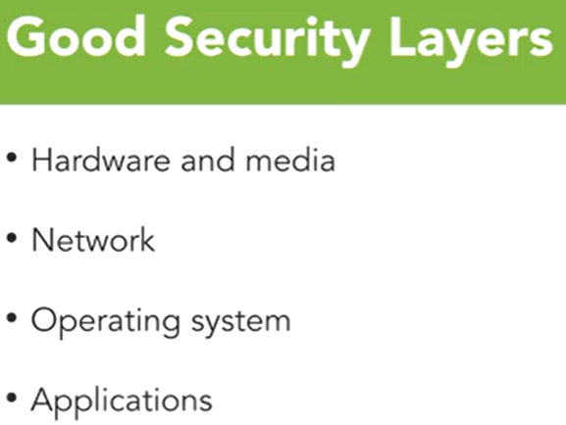

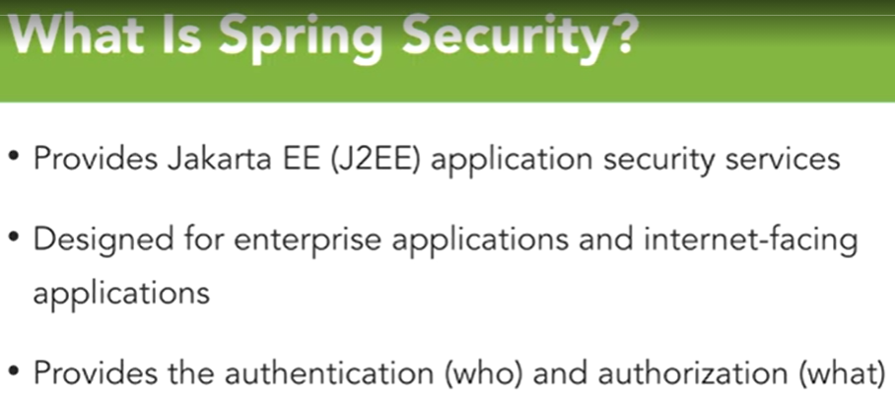

* When you build an authentication system, you usually do so either from an external provider or from a database system connected to your application.
* Spring Security provides Domain Object Instance, Web Request, and Method Invocation based Authorization access controls.
* Spring Security relies on principals, so we need a way to build and translate principals and users. For that, a class that implements the *UserDetails* interface needs to be created.
* NEVER user a plain-text password encoder for production.
* Don’t encrypt but hash passwords instead.

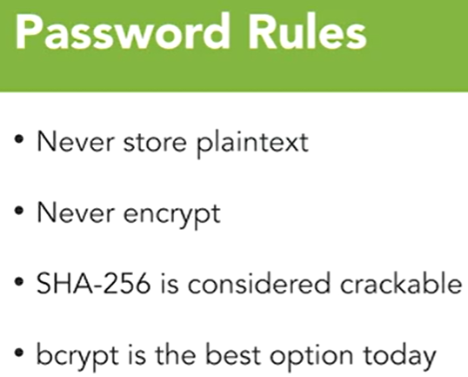

* One of the biggest issues with Basic Authentication is the inability to log off. Everything is session based with Basic Authentication, and there’s not a real unified way to handle logging off across all the browsers. Basic Authentication doesn’t give the option to modify the login window either.

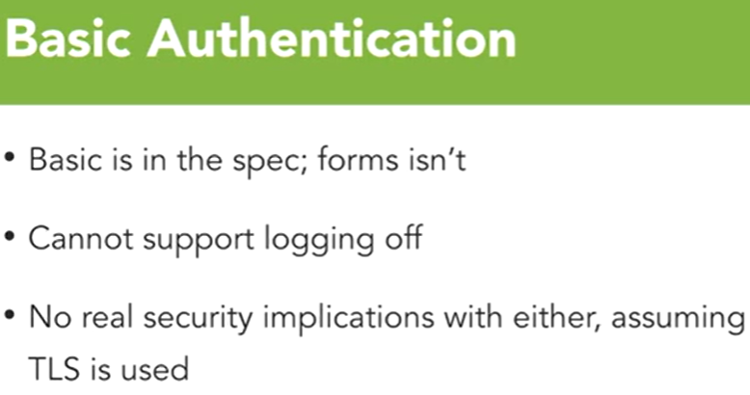

* Form-based Authentication solves some of the issues mentioned before, but keep in mind that TLS still needs to be leveraged to secure the credentials on the wire.

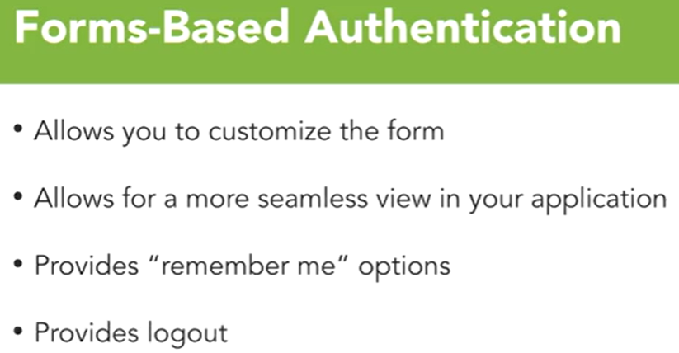

* When building a connection to a database, use *DaoAuthenticationProvider* as the AuthenticationProvider.
* One of the biggest benefits of **LDAP** is its interoperability among many different OSs and components. Its services are exported to many of those components so that they don’t natively have to support authentication.

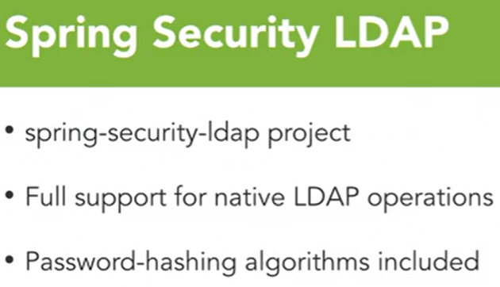

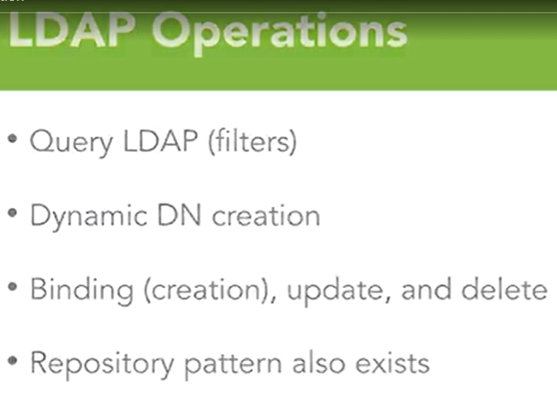

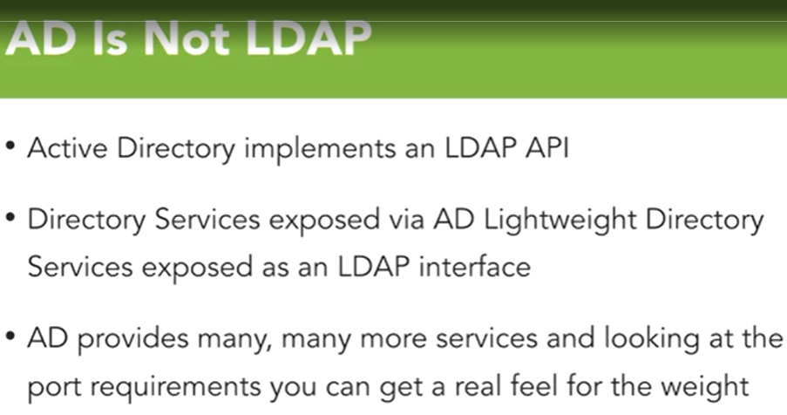

* **OAuth2** is a protocol and a framework for providing access to HTTP services. Those services can be traditional web services as well as web applications. It also can be used to system-to-system communications in standalone mode or on behalf of another user.
* Key components in an OAuth2 system:
  + **Resource Owner** – the data that actually is being protected. Often the user is the owner.
  + **Client** – application being used, or service that is being used on my behalf that is requesting access to the resource.
  + **Resource Server** – it is the system that hosts the protected data and the accounts that we’re requesting access to.
  + **Authorization Server** – the service that grants tokens on behalf of me to the data that the resource server itself holds.

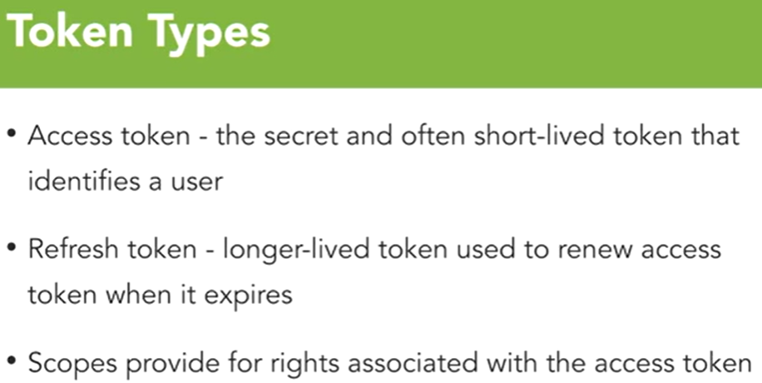

* There are different types of **Grants** and they impact the flow throughout the system.
  + Authorization Code – the most common.
  + Implicit – very common in web apps and mobile apps where the security of the access token cannot be maintained. Often they don’t come with refresh tokens, and they are very specific to the function of the application being granted access.
  + Client Credential – each system gets a client ID in secret that uses to get an access token to then do its work within the system, based on the scopes previously defined.
* Spring has full integration for OAuth2. One of the first classes you may interact is *CommonOAuth2Provider*, which is used to connect to such systems as Okta, Facebook, Google, and several other OAuth providers. It also provides client-side OAuth integration, and allows to provide 3rd party support for the logging operations.
* The *AuthorizationServer* provides authorization and authentication services to the system as a whole. Many companies choose to have their own internal authorization server to provide the utility not only to their mobile applications but also for their internal services. Creating the service is done using the annotation *@EnableAuthorizationServer*. An *AuthorizationServerConfigurerAdapter* is used to configure the Authorization Server when it’s going to be used.
* The *ResourceServer* provides the resources that are being protected. Configuration is done by using the *@EnableResourceServer* annotation.
* The OAuth2 Client allows to have full client support for OAuth systems. To enable it, use the annotation *@EnableOAuth2Client*.
* The *OAuth2RestTemplate* manages all of the tokens, manipulation, and injection of those tokens into the headers.

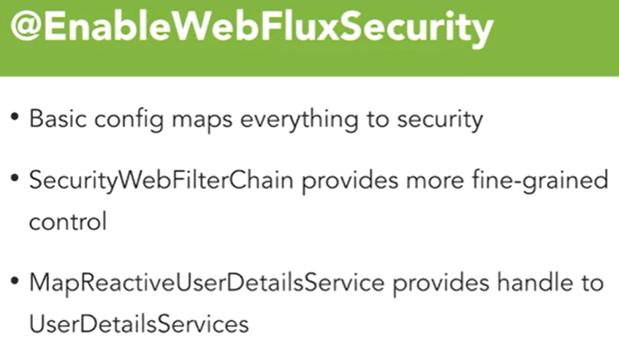

*************************************************************************************

**BUILDING FULL-STACK APPS WITH REACT AND SPRING**

*************************************************************************************

* **React** has been a solid offering for building front-end applications and has quickly become the number one framework for this purpose. React Native can be used to build mobile applications.

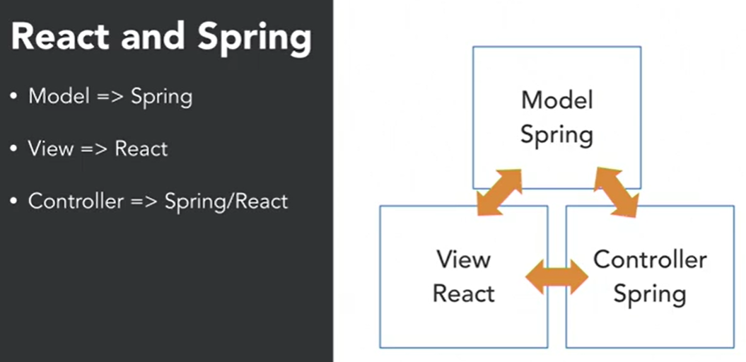

* To initialize a React project, open the folder where your project is located and run a CMD. What the command will do is that it will temporarily download the React app inside your system and then create a new React client inside the project. The command is: **npx create-react-app client**
* Run **npm install** and **npm audit fix –force** if having issues when launching the React project.